EXHIBIT LIST

EXHIBIT LIST
- Exhibit A: "Child exposure to porn text chain"
- Exhibit B: “Gilstrap’s documented misconduct”
- Exhibit C: Complaint to Chief Schlude
- Exhibit D: DoJ submissions (initial and revised) [establishes initial Sept 1 filing date]
- Exhibit E: High Intent Google searches for monetization on OnlyFans
- Exhibit F: Affair expenses
- Exhibit G: bank/cc statements plus image of hotel room that matches video
- Exhibit H: regulatory complaint
- Exhibit I: Attempt to extract equity from house via HELOC immediately pre divorce
- Exhibit J: Dr. Freed’s ADHD Report
- Exhibit K: February 2026 email from Petitioner conceding claims to Respondent’s business
- Exhibit L: Limerence Journal entry
- Exhibit M: "it worked" email chain
- Exhibit N: "financial documents" email chain
- Exhibit O: pattern of bad faith and failure to honor pre existing financial agreements
- Exhibit P: key admissions by Meers’ attorney regarding revenge porn
- Exhibit Q: Title Deed and Mortgage Loan for Newton, KS property
- Exhibit R: Financial records showing income perjury on Petitioners Form 14
- Exhibit S: Total shared tuition and school fee obligations
- Exhibit T: Petitioner’s unilateral mortgage account modification
- Exhibit U: Petitioner’s performative mediation request
- Exhibit V: Senator Hawley’s casework team engaged in my request for coordination
- Exhibit W: Petitioner demanding deletion of criminal evidence during police investigation
- Exhibit Y: EXIF sha-hashed metadata of intimate content found on child’s iPad shared by Petitioner with Ben Meers (yellow rows indicate videos containing intimate content including Respondent, shared non-consensually)
- Exhibit Z: Transcript from the October 15, 2024 “casting couch video”, the first video that was discovered on the child’s iPad
- Exhibit AA: Pictures and video taken from phone of iPad day of discovery of content
- Prior History with Ben Meers - casual chat from 2013 between Petitioner and friend about Meers’ choking petitioner during sex
- Post-mortem with couples therapist who enabled Amber’s abusive behaviors during 2023

Exhibit A
Exhibit A

Conversation with Amber McIntosh following discovery of her content on our child’s iPad. I deleted the videos from the iPad but preserved the content separately per state law requirements and per my right as victim of revenge porn
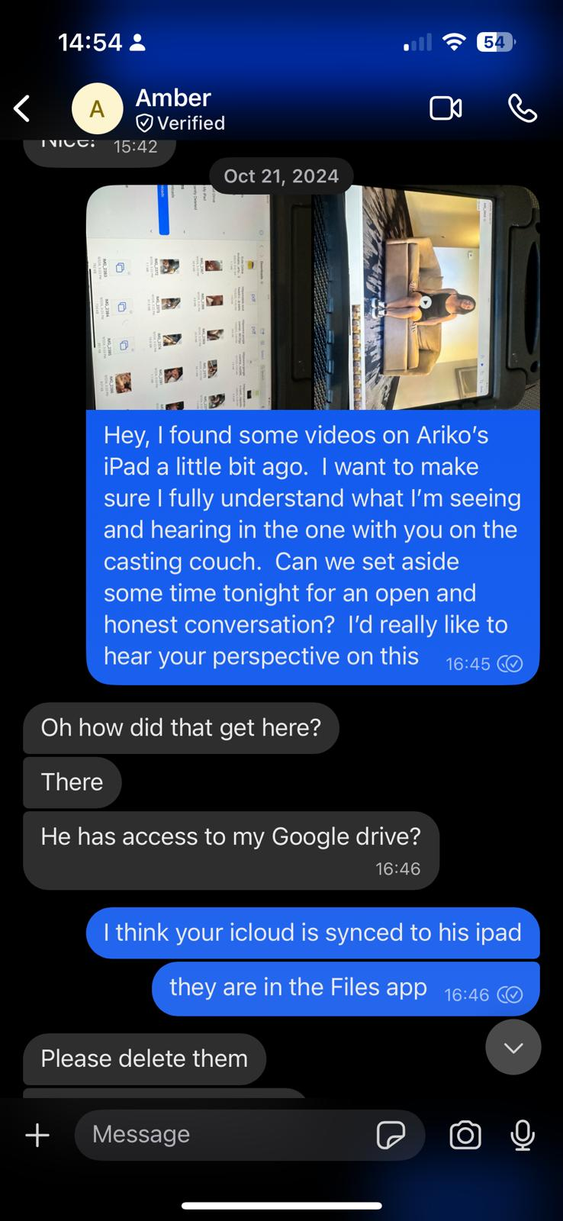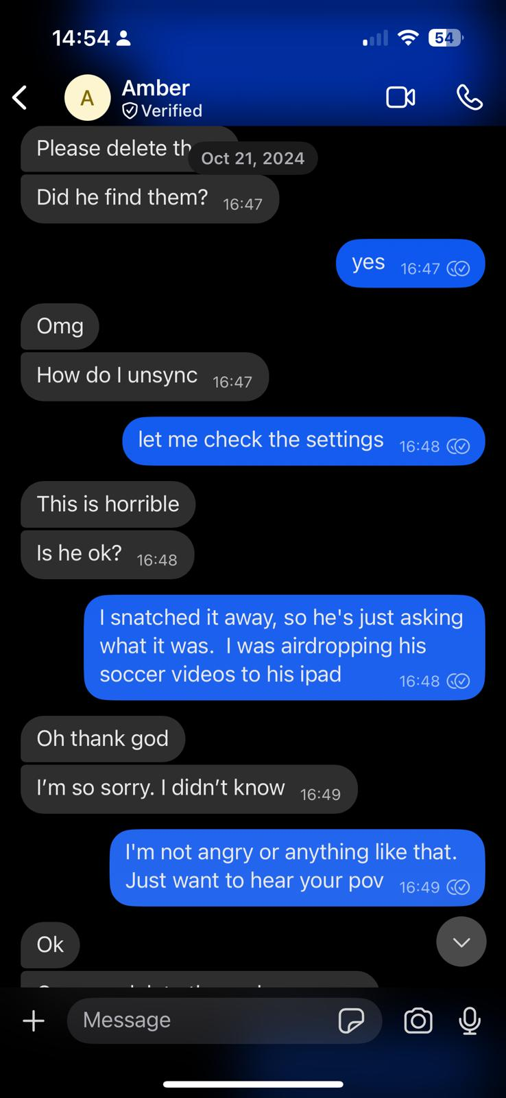;

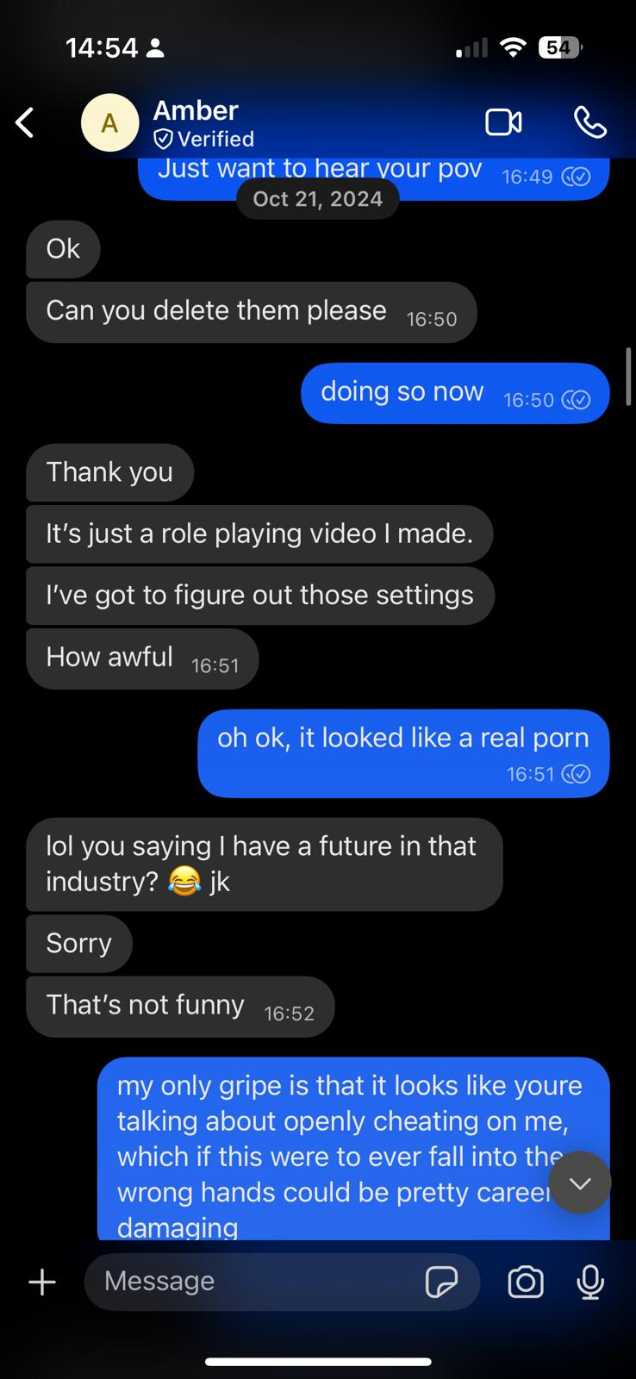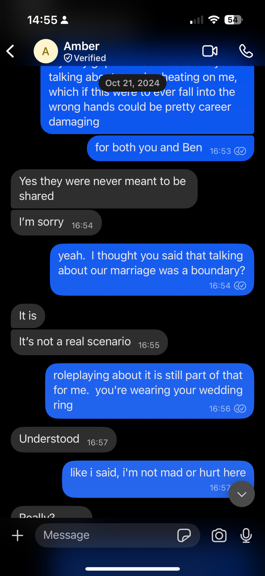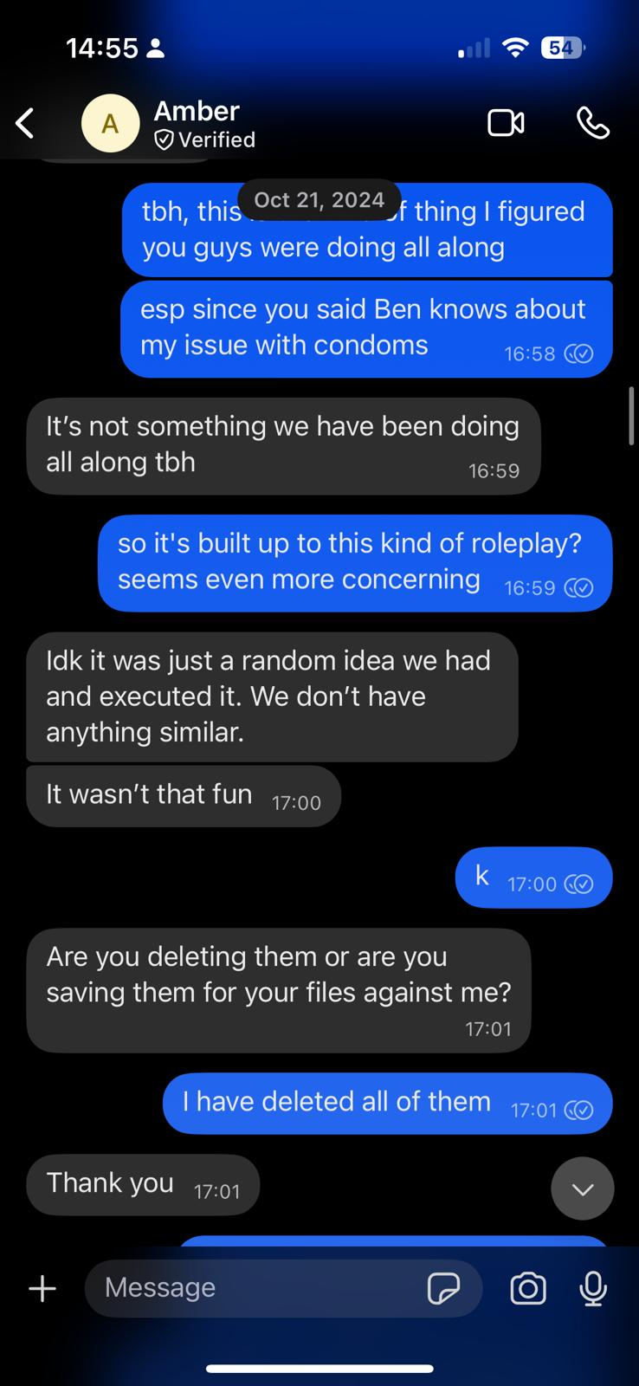

Exhibit B
Exhibit B

Officer Gilstrap’s documented deletion of evidence of child exposure to pornography and denial of legal standing to all other named victims outside of Petitioner. He chose not to respond to my last note.
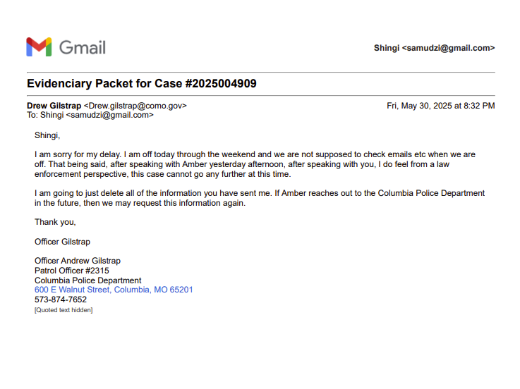
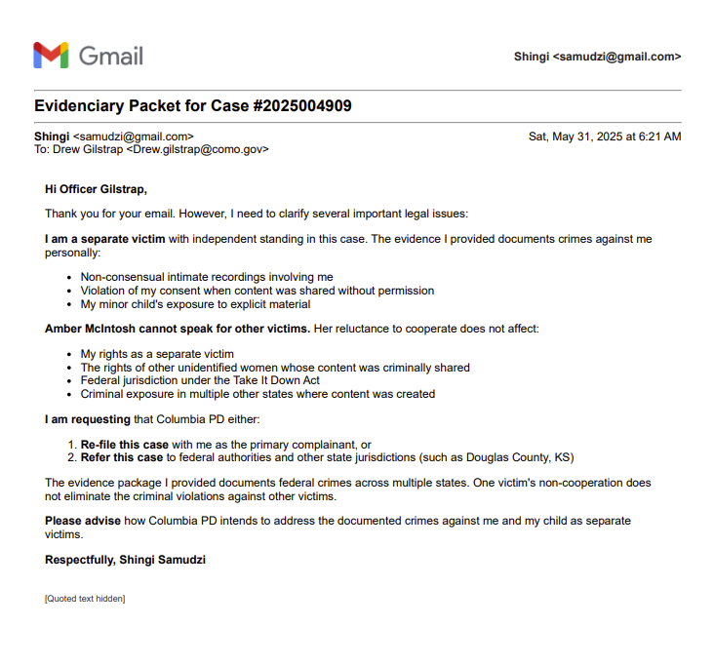

Exhibit C
Exhibit C

Complaint to Columbia Police Department Chief Schlude that triggered Internal Affairs investigation
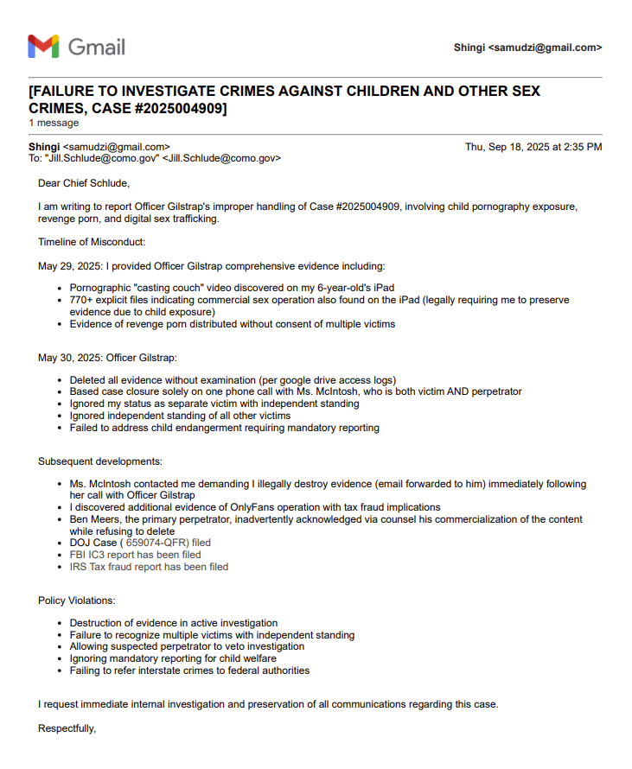

Exhibit D
Exhibit D
DoJ Submission
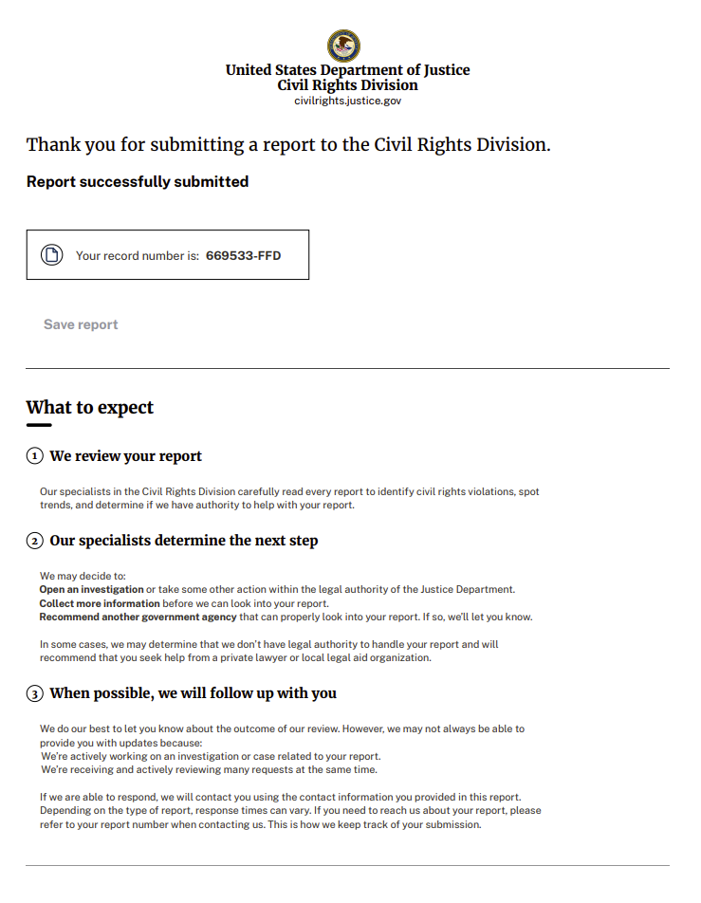
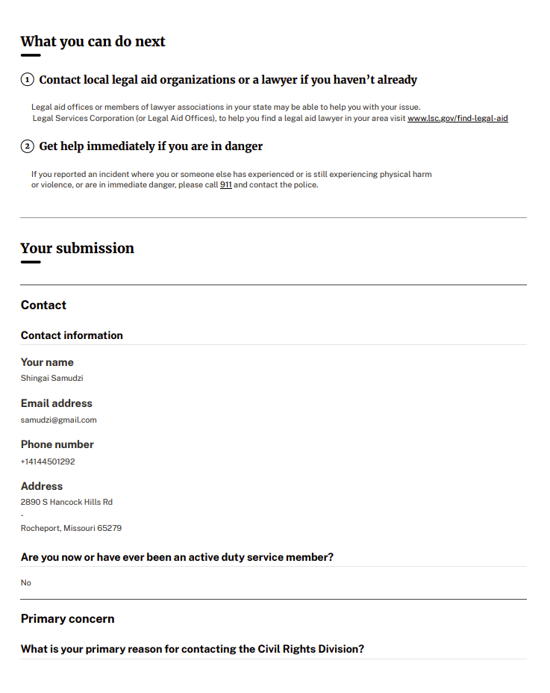
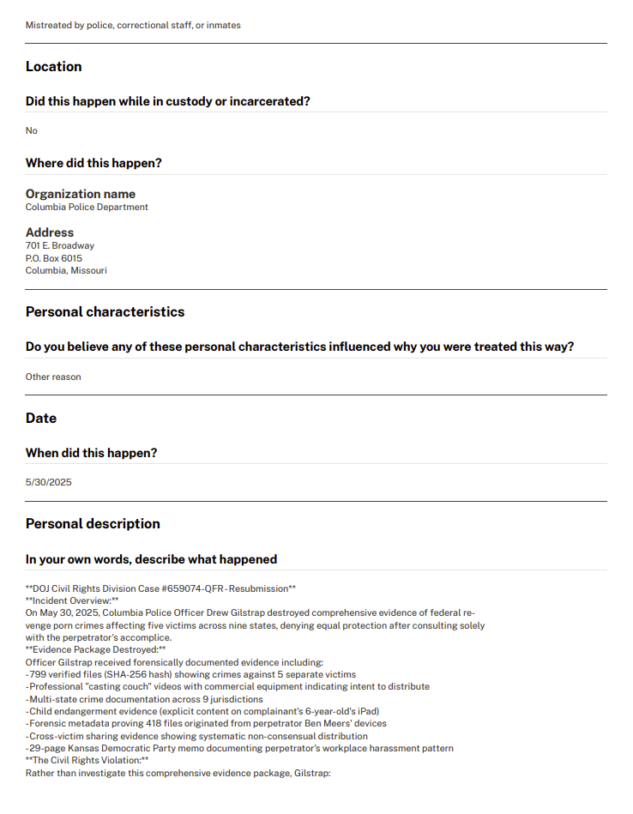
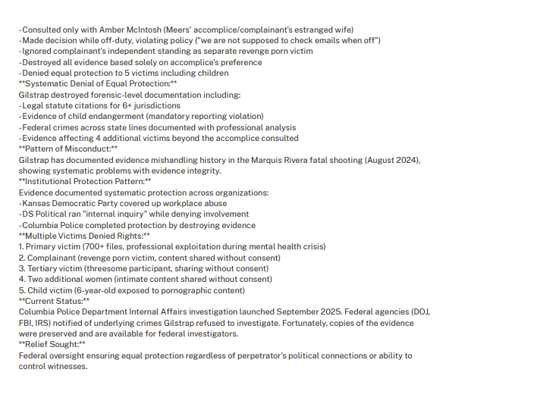

Exhibit E
Exhibit E

High intent Google searches from mcintosh.amberrenee@gmail.com account, found on child’s iPad, concentrated in a 7 hour period from July 19 evening into early morning July 20
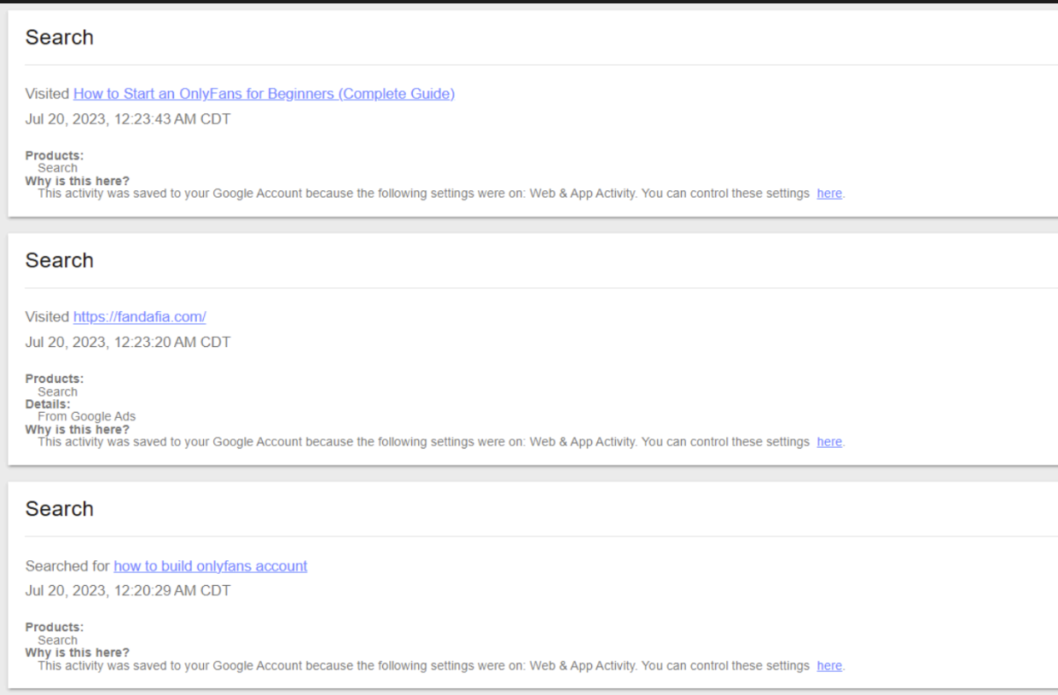
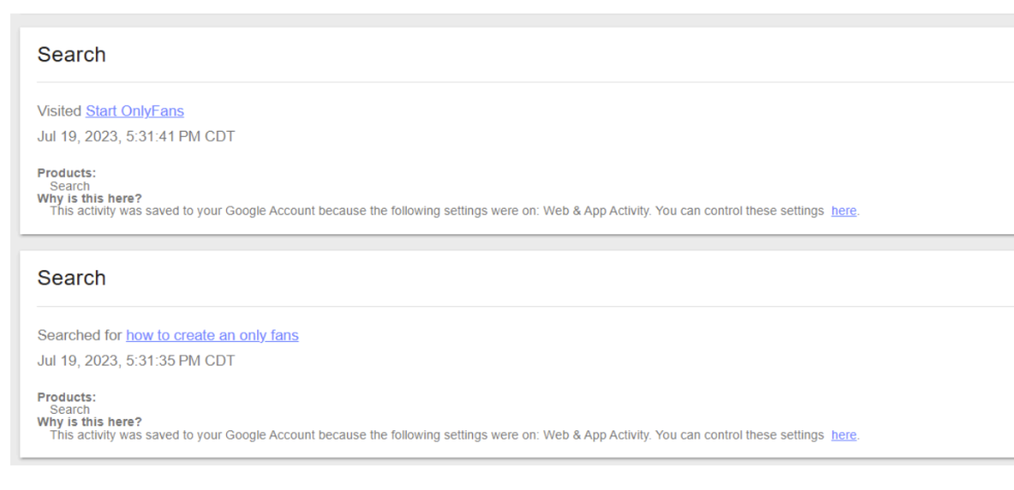

Exhibit F
Exhibit F

Marital Misuse of Funds; Withdrawals from Capital One Joint Account 4806

Karallyn Streit is a licensed massage therapist and “shamanic healer” in North Carolina whom Petitioner referred to as her “therapist”, saw on a near weekly recurring basis while living in California and then Missouri (where Ms Streit has no license whatsoever yet claimed illegally per North Carolina state law to treat mental health disorders such as PTSD), and used as primary psychotherapist in lieu of seeing actual licensed mental health professionals for formally diagnosed mental health conditions
Date | Complete Line Item | Amount
Jul 16, 2022 | Debit Card Purchase - VENMO 8558124430 NY | $480.00
Sep 3, 2022 | Debit Card Purchase - VENMO 8558124430 NY | $360.00
Oct 14, 2022 | Debit Card Purchase - VENMO 8558124430 NY | $360.00
Dec 3, 2022 | Debit Card Purchase - VENMO 8558124430 NY | $360.00
Jan 14, 2023 | Debit Card Purchase - VENMO 8558124430 NY | $360.00
Jul 24, 2023 | Debit Card Purchase - VENMO KARALLYN STREI 8558124430 NY | $120.00
Aug 21, 2023 | Debit Card Purchase - VENMO KARALLYN STREI 8558124430 NY | $120.00
Sep 15, 2023 | VENMO PAYMENT IAT PAYPAL 8558124430 CA | $480.00
Sep 18, 2023 | Debit Card Purchase - VENMO KARALLYN STREI 8558124430 NY | $120.00
Oct 23, 2023 | Debit Card Purchase - VENMO KARALLYN STREI 8558124430 NY | $120.00
Nov 20, 2023 | Debit Card Purchase - VENMO KARALLYN STREI 8558124430 NY | $120.00
Dec 18, 2023 | Debit Card Purchase - VENMO KARALLYN STREI 8558124430 NY | $120.00
Jan 22, 2024 | Debit Card Purchase - VENMO KARALLYN STREI 8558124430 NY | $120.00
Jan 31, 2024 | VENMO PAYMENT IAT PAYPAL 8558124430 CA | $360.00
Feb 20, 2024 | Debit Card Purchase - VENMO KARALLYN STREI 8558124430 NY | $120.00
Mar 19, 2024 | Debit Card Purchase - VENMO KARALLYN STREI 8558124430 NY | $120.00
Apr 16, 2024 | Debit Card Purchase - VENMO KARALLYN STREI 8558124430 NY | $120.00
May 4, 2024 | Debit Card Purchase - VENMO KARALLYN STREI 8558124430 NY | $240.00
May 23, 2024 | Debit Card Purchase - VENMO KARALLYN STREI 8558124430 NY | $240.00
Jun 6, 2024 | Debit Card Purchase - VENMO KARALLYN STREI 8558124430 NY | $120.00
Jun 14, 2024 | Debit Card Purchase - VENMO KARALLYN STREI 8558124430 NY | $120.00
Jul 12, 2024 | Debit Card Purchase - VENMO KARALLYN STREI 8558124430 NY | $110.00
Jul 15, 2024 | Debit Card Purchase - VENMO KARALLYN STREI 8558124430 NY | $10.00
Jul 18, 2024 | Debit Card Purchase - VENMO KARALLYN STREI 8558124430 NY | $120.00
Jan 21, 2023 | Debit Card Purchase - KARALLYN STREIT ASHEVILLE NC Debit | $130
Total $5,050.00

Affair Spending
Each of the following represent clusters of spending related to travel and expenses incurred from the Capital One Joint Account in pursuit of her extramarital affair, spanning from July 2021 to July 2024

Kansas City July 2021
Jul 28 Debit Card Purchase - WESTIN KANSAS CITY KANSAS CITY MO Debit - $205.35
Aug 2 Aug 3 ENTERPRISE RENT-A-CARCOLUMBIAMO $615.46

New Mexico August 2023
Aug 11 Debit Card Purchase - MARIN AIRPORTER 415 2568833 CA Debit - $28.00
Aug 13 Digital Card Purchase - JASONS DELI UPTOWN AB ALBUQUERQUE NM Debit - $14.27
Aug 13 Digital Card Purchase - TARGET 00028134 ALBUQUERQUE NM Debit - $2.04
Aug 13 Digital Card Purchase - TARGET 00028134 ALBUQUERQUE NM Debit - $8.44
Aug 15 Debit Card Purchase - FRONTIER RESTAURANT ALBUQUERQUE NM Debit - $13.24
Aug 15 Digital Card Purchase - SQ TUMBLEROOT BREWERY SANTA FE NM Debit - $18.14
Aug 15 Debit Card Purchase - CASA CULINARIA THE GO SANTA FE NM Debit - $44.87
Aug 15 Debit Card Purchase - OKEEFFE MUSEUM SANTA FE NM Debit - $40.00
Aug 16 Digital Card Purchase - HUDSON ST2161 ALBUQUERQUE NM Debit - $15.04
Aug 16 Debit Card Purchase - UBER TRIP 8005928996 CA Debit - $29.58
Aug 16 Digital Card Purchase - SQ KEVA ABQ AIRPORT ALBUQUERQUE NM Debit - $10.01
Aug 15 Debit Card Purchase - DELTA DELTA COM CA Debit - $347.20

Seattle May 2022
May 11 Debit Card Purchase - THE SONOMA COUNTY AIRP 707 837 8700 VA Debit - $32.00
May 12 Debit Card Purchase - SOUND TRANSIT SO QPS SEATTLE WA Debit - $3.00
May 13 Digital Card Purchase - BARTELL DRUG 06901 SEATTLE WA Debit - $29.52
May 13 Digital Card Purchase - SQ 1600 ANCHORHEAD CO SEATTLE WA Debit - $20.40
May 13 Digital Card Purchase - SQ BOSTON STREET BABY SEATTLE WA Debit - $161.30
May 14 Digital Card Purchase - ARAMARK - ARAMARK - MO SEATTLE, WA US Debit - $3.99
May 14 Digital Card Purchase - ARAMARK - ARAMARK - MO SEATTLE, WA US Debit - $11.54
May 15 Debit Card Purchase - LE PICHET SEATTLE WA Debit - $9.16
May 15 Debit Card Purchase - TST THE PINK DOOR SEATTLE WA Debit - $184.35
May 15 Digital Card Purchase - TST SABINE SEATTLE 206 453 5014 WA Debit - $32.62
May 15 Debit Card Purchase - SQ VERVE BOWLS BALL SEATTLE WA Debit - $23.00
May 16 Debit Card Purchase - MOSHI MOSHI SUSHI SEATTLE WA Debit - $44.38
May 16 Debit Card Purchase - CASH APP ELDON BARR 4153753176 CA Debit - $20.00
May 16 Debit Card Purchase - SEA KOISHISUSHIBENTOCT TUKWILA WA Debit - $16.39
May 17 Debit Card Purchase - BALLARD INN 206 7895011 WA Debit - $391.07
May 17 Debit Card Purchase - LYFT 1 RIDE 05 15 8558659553 CA Debit - $71.71
May 12 ATM Withdrawal - HAVE A HEART BELL TO GM009448 SEATTLE, WA Debit - $103.95
May 8 Debit Card Purchase - AIRBNB HMNMTN3CR2 4158005959 CA Debit - $1,169.71

San Diego January 2024
Jan 7 Debit Card Purchase - AMERICAN SEATTLE WA Debit - $359.60
Jan 13 Digital Card Purchase - RITE AID 06466 SAN DIEGO CA Debit - $18.73
Jan 13 Digital Card Purchase - SHAKE SHACK 1206 SAN DIEGO CA Debit - $28.82
Jan 14 Digital Card Purchase - 7-ELEVEN SAN DIEGO, CA US Debit - $10.76
Jan 14 Digital Card Purchase - COFFEE N TALK BROADW SAN DIEGO CA Debit - $7.99
Jan 14 Digital Card Purchase - LYFT 1 RIDE 01 11 8558659553 CA Debit - $31.14
Jan 14 Digital Card Purchase - HOTELTONIGHTTHE GUILD 8333380302 CA Debit - $191.00
Jan 15 Debit Card Purchase - LYFT 2 RIDES 01 13 8558659553 CA Debit - $24.02
Jan 15 Debit Card Purchase - LYFT 2 RIDES 01 12 8558659553 CA Debit - $27.37
Jan 15 Digital Card Purchase - SAN PEETS COFFEE T1W 3 SAN DIEGO CA Debit - $8.82

Las Vegas March 2023
Mar 11 Debit Card Purchase - EXPEDIA 72509195261433 EXPEDIA COM WA Debit - $169.34
Mar 14 Debit Card Purchase - SPIRIT AI MIRAMAR FL Debit - $135.00
Mar 14 Debit Card Purchase - HENDERSONTAXI LAS VEGAS NV Debit - $28.86
Mar 15 Digital Card Purchase - HUDSON DUNKIN ST1599 LAS VEGAS NV Debit - $11.81
Mar 15 Digital Card Purchase - VHLV FUNNY LIBRARY LAS VEGAS NV Debit - $18.20
Mar 15 Digital Card Purchase - PIZZA FORTE LAS VEGAS NV Debit - $20.42
Mar 15 Digital Card Purchase - LYFT 1 RIDE 03 12 8558659553 CA Debit - $54.98
Mar 16 Debit Card Purchase - SPIRIT AI MIRAMAR FL Debit - $12.00
Mar 16 Digital Card Purchase - VHLV FUNNY LIBRARY LAS VEGAS NV Debit - $30.18
Mar 16 Digital Card Purchase - VHLV THE SPA LAS VEGAS NV Debit - $504.00
Mar 17 Debit Card Purchase - VHLV LODGING LAS VEGAS NV Debit - $155.84
Mar 17 Digital Card Purchase - LYFT 1 RIDE 03 14 8558659553 CA Debit - $50.99

Dallas February 2023
Feb 2 Debit Card Purchase - SP DALLIANSE SANTA FE NM Debit - $49.95
Feb 3 Digital Card Purchase - CVS PHARMACY 10670 DALLAS TX Debit - $25.14
Feb 3 Debit Card Purchase - LYFT 1 RIDE 02 01 8558659553 CA Debit - $128.66
Feb 4 Zelle money sent to KATHERINE DESSERT Debit - $225.00
Feb 4 Digital Card Purchase - KIMPTON PITTMAN F B DALLAS TX Debit - $27.32
Feb 5 Debit Card Purchase - THE KIMPTON PITTMAN HT DALLAS TX Debit - $685.97
Feb 1 Debit Card Purchase - LYFT 2 RIDES 01 30 8558659553 CA Debit - $104.19

Lawrence November 2022
Nov 15 Digital Card Purchase - TURO INC TRIP NOV 14 SAN FRANCISC CA Debit - $616.90
Nov 16 Digital Card Purchase - THE MERC COOP LAWRENCE KS Debit - $58.96
Nov 16 Digital Card Purchase - THE MERC COOP LAWRENCE KS Debit - $10.48
Nov 18 Debit Card Purchase - REPLAY LOUNGE LAWRENCE KS Debit - $23.50
Nov 18 Debit Card Purchase - LUCKY SEBS DUMPLING BA LAWRENCE KS Debit - $28.75
Nov 19 Digital Card Purchase - SQ 1900 BARKER BAKE LAWRENCE KS Debit - $27.22

Las Vegas March 2024
Mar 19 Digital Card Purchase - MGM GRAND GRAND CO LAS VEGAS NV Debit - $12.00
Mar 19 Digital Card Purchase - STARBUCKS BAGGAGE LAS LAS VEGAS NV Debit - $6.50
Mar 19 Digital Card Purchase - PAYPAL UBER 4029357733 CA Debit - $22.97
Mar 19 Debit Card Purchase - SHANGHAI TASTE CHICAGO IL Debit - $37.53
Mar 20 Digital Card Purchase - AUNTIE ANNE S NV109 LAS VEGAS NV Debit - $11.82
Mar 20 Digital Card Purchase - AUNTIE ANNE S NV109 LAS VEGAS NV Debit - $6.11
Mar 17 Digital Card Purchase - VIP SAN RAFAEL SAN RAFAEL CA Debit - $31.67
Mar 17 ATM Withdrawal - 000000000129760 NH054489 LAS VEGAS, NV Debit - $67.00

Kansas City July 2024
July 6 [Amount Petitioner requested to be sent to joint account for “trip to Kansas City”] $120

Total $7,947.24

Sum Total $12,997.24

Exhibit G
Exhibit G

Credit Card Statement showing processed payment for car rented for travel to Kansas City. Amber used my credit card to pay (see Transaction date August 2, 2021 for $615.46 from Enterprise Rent a Car)
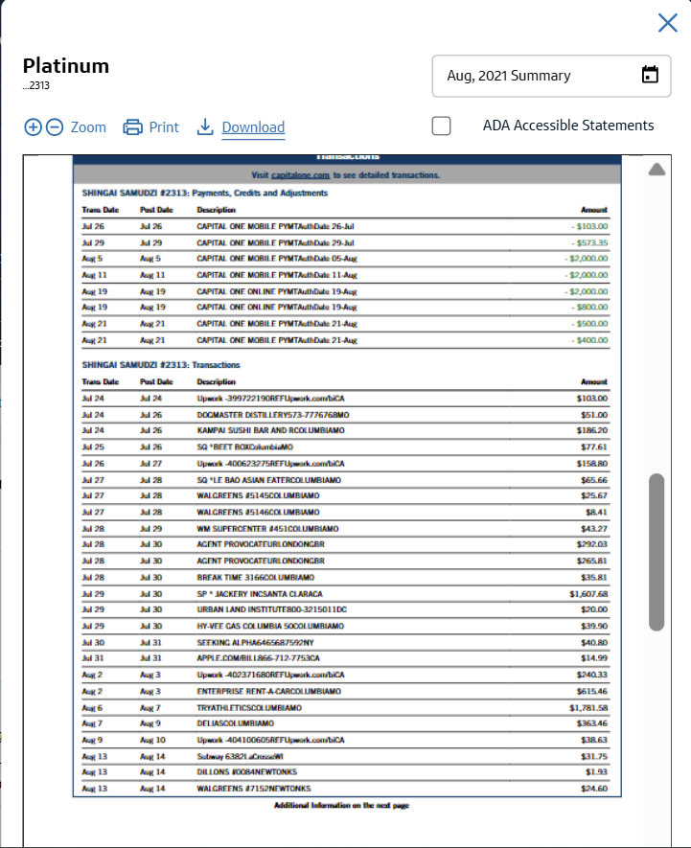

Joint Checking Account statement showing processed payment for room at Westin Hotel, Crown Center in Kansas City (see transaction date July 28, 2021 for $205.35)
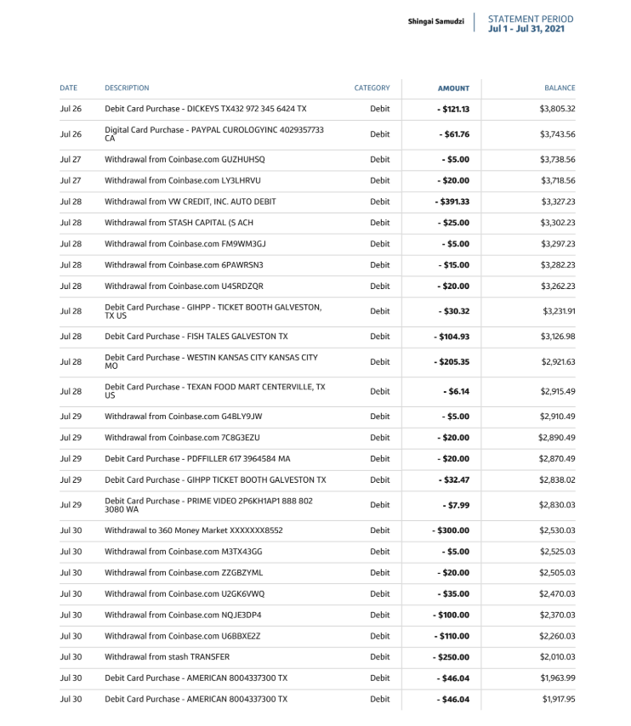

Room design and furniture that matches room seen in videos IMG_7039.mp4 and IMG_7071.mp4, a recorded sexual encounter from 7/28 between Petitioner and Ben Meers found on our child’s iPad

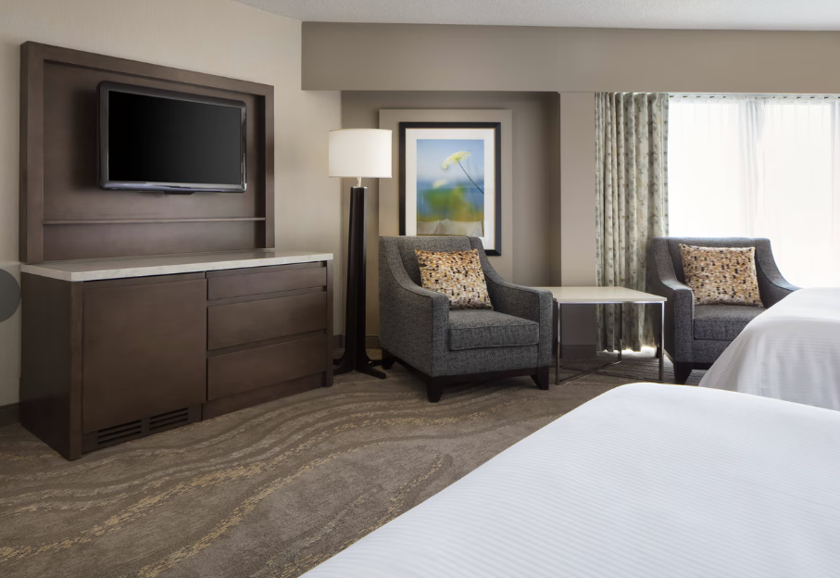

Exhibit H
Exhibit H

Regulatory complaint against unlicensed therapist Karallyn Streit
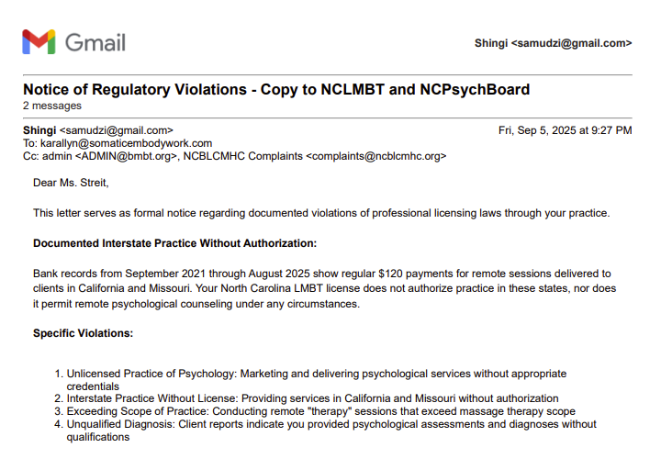
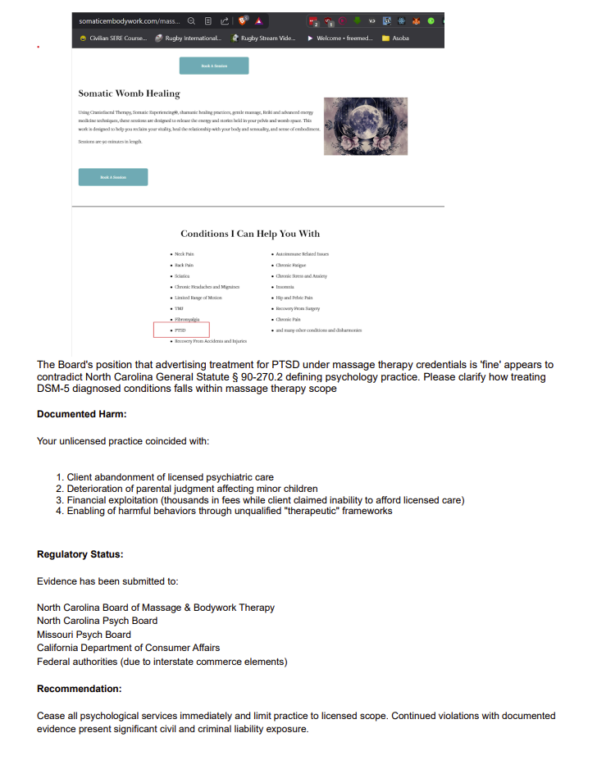
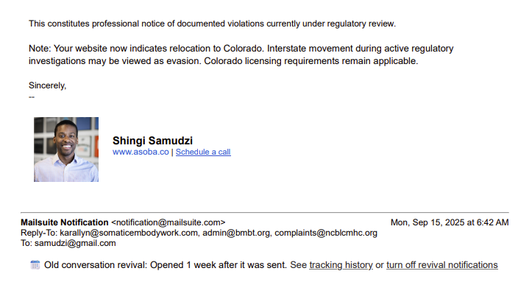

Exhibit I
Exhibit I
Petitioner’s attempt to hustle a HELOC
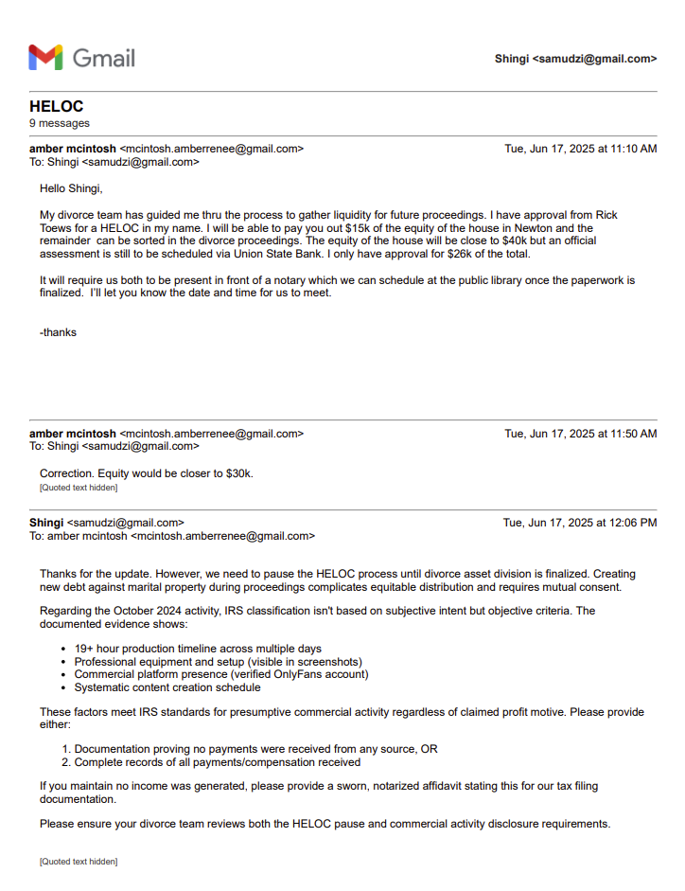
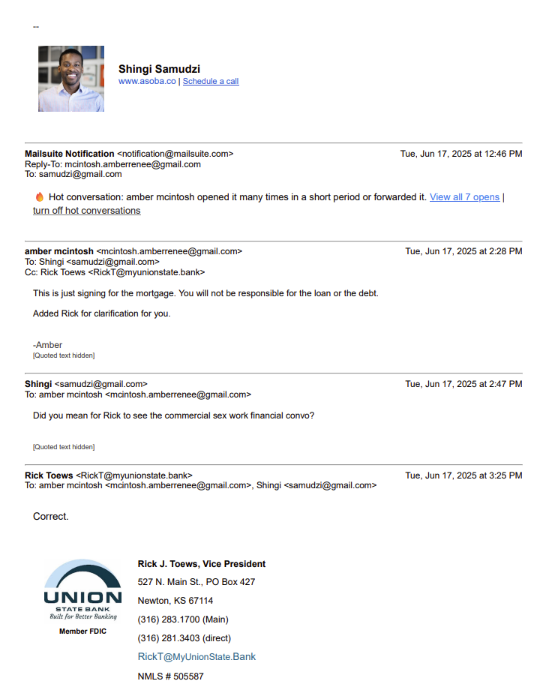
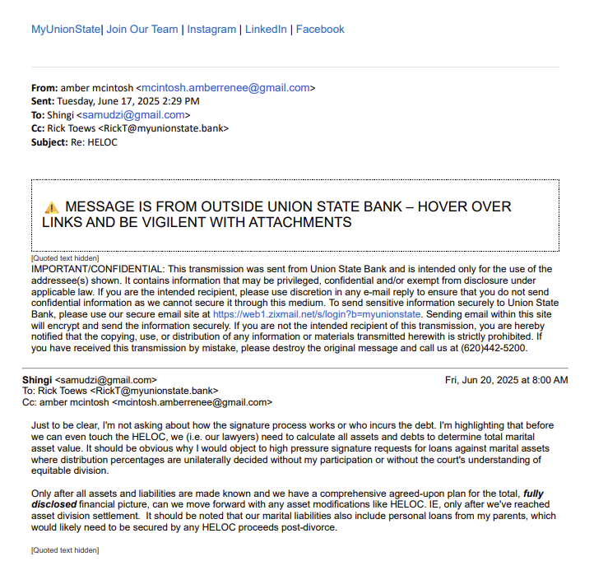

Exhibit J
Exhibit J

ADHD assessment shared by Petitioner with me in June 2023 from Dr. Freed of the Marin Center for Attention suggesting strong behavioral markers for ADHD, and highlighting the ongoing risks of her continued refusal of clinical licensed mental health behavioral support

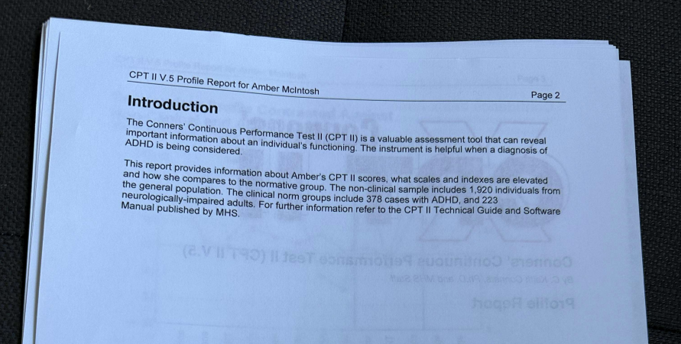

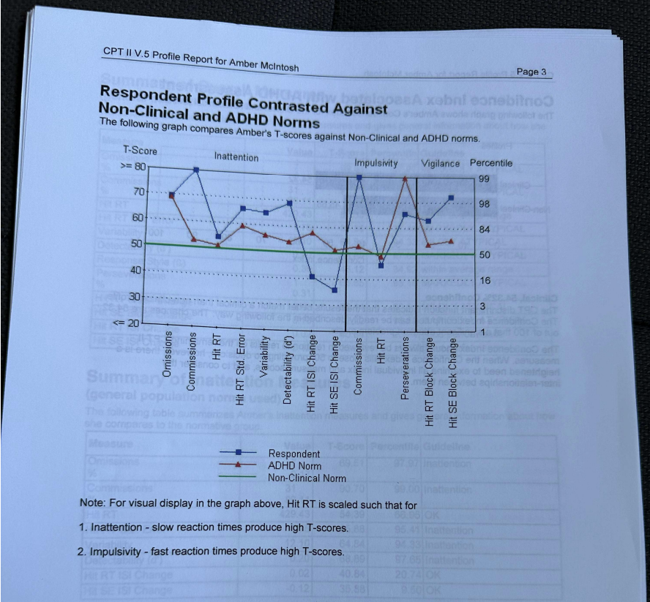

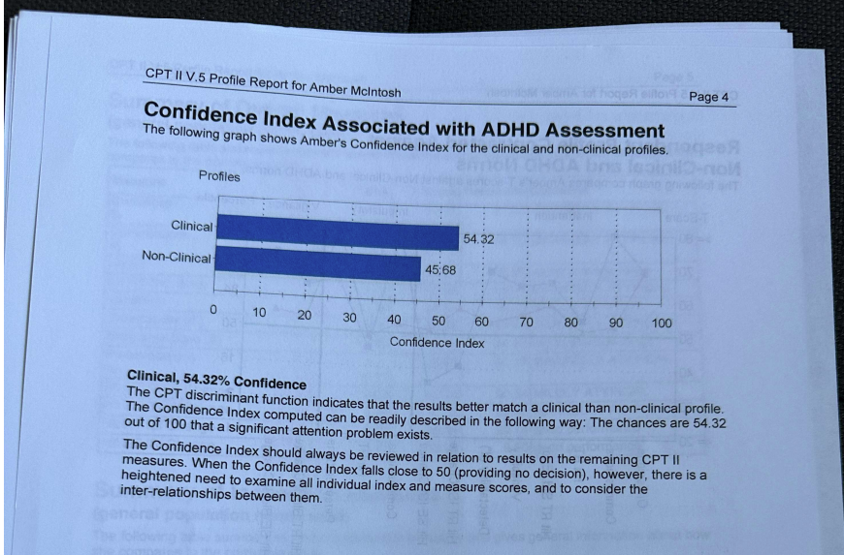

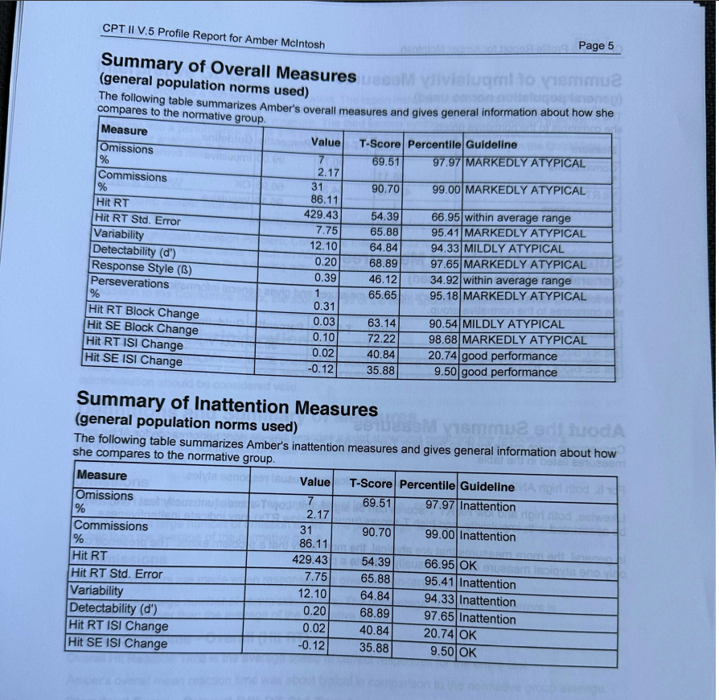

Amber’s notes from the session, note that she failed to follow through with any of the recommendations citing financial constraints, yet spend several thousand dollars over the following months (enough to pay the $3300 fee) on travel and accommodations for content creation with Ben:

Jun 29, 2023, 2:28:17 PM
2/3rds the size of nero or ep
intuitive
bright
reactive
pay attmn
contrll emotions
3d ppl in 2d wrld
hard to stay on top of thigs
self esteem
hard to ptior
procrastivity
we thought aboyt it but didnt do
crazy making
then struggle
1/2 ppl who are bi-polar have adhd
treatable? we will figure that out
gift to have it if i can overcome the inefficiency of it
bipolar - normal dep get behind in seritoni ie why lex
bipolar the productio is off then can create too much
i could have both disorders
start by controling bi-polar
adhd can trigger the bi-polar

the way hes done it
he's looking for a function result
not medication
once i understand how my brain works then i can build methods
coaching comes in from that
90 min consult in th emorning and gives a test and shows patterns of attention - go over the test
2nd session 90 mins then we put it all together
then if he has to subscribe med then he takes at least 2 weeks to work together to get the meds correct and assess where i benefit
he likes to share coaching and info along the way

make up statements to bill insurance -

1 fee for the entire process - goal is to get me to a functional understanding then provide coaching and success usually comes quickly

FEE - Credit Card can pay how
$3,300 for the entire - payment arrangement or installments

they all cause fatige which conflicts w/ ridalin

Exhibit K
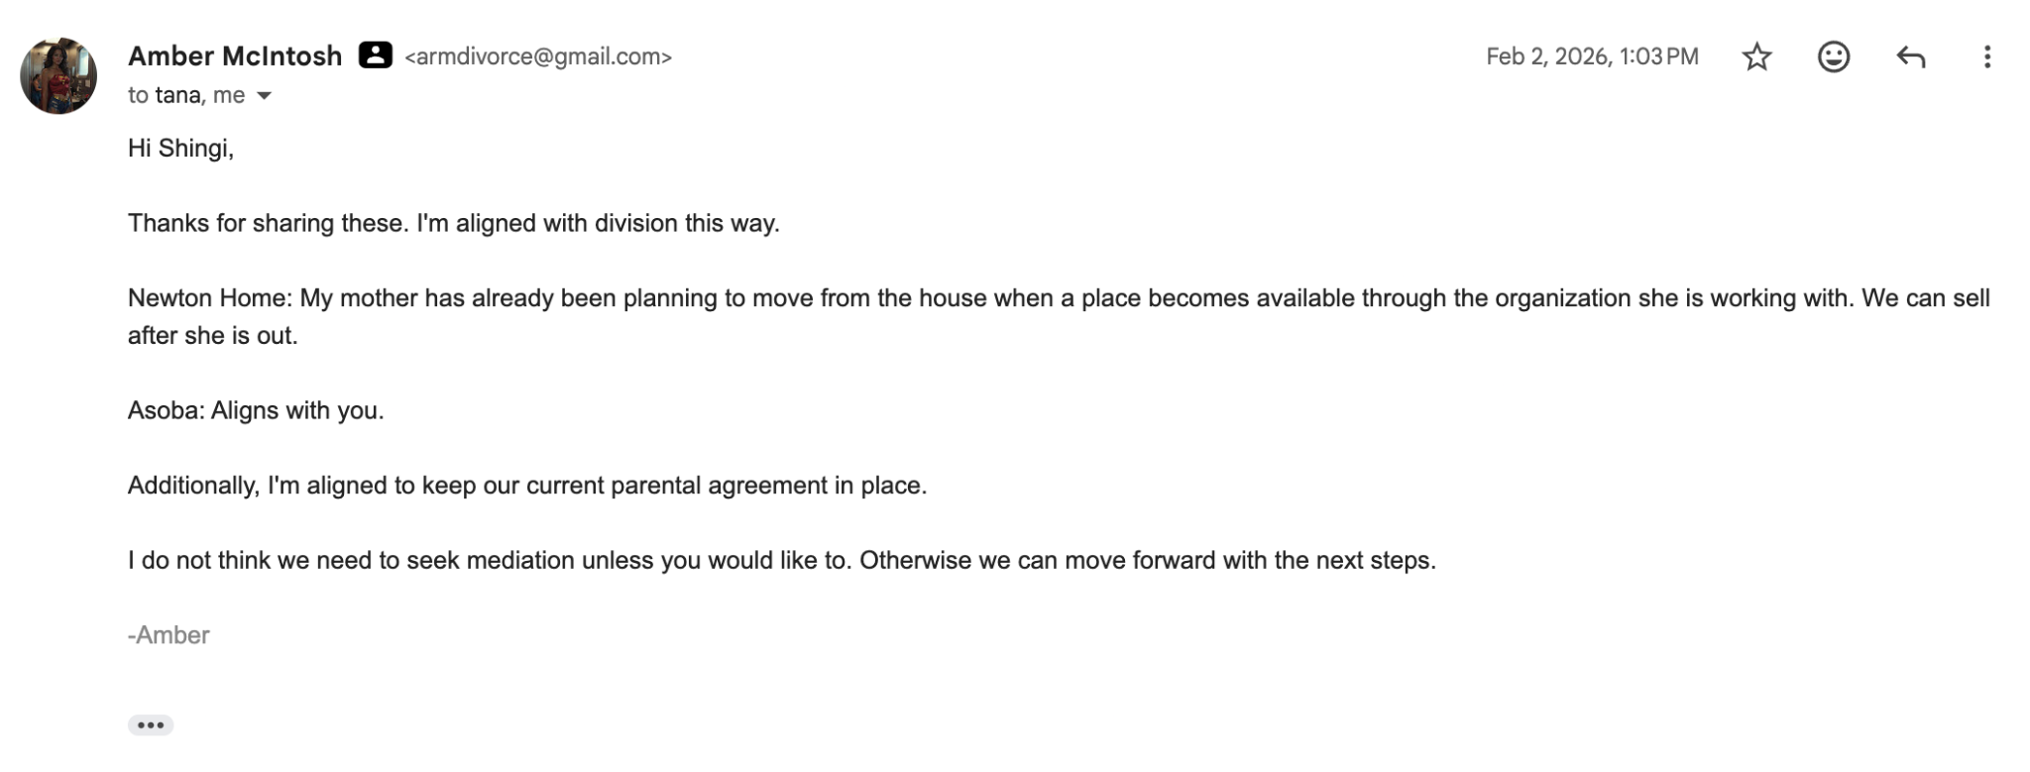

Exhibit L
Exhibit L

Journal entry found on son’s iPad that highlights the obsessive, limerent, emotionally unrequited nature of Petitioner’s relationship with her affair partner Ben Meers. It also shows the foundation of her decision to push for a move from California to Missouri in 2024, to achieve greater geographic proximity

Apr 1, 2024, 11:04:09 AM
Keep things in perspective
B likes being alone
He only does what he wants.
No interest in enmeshment

anxious avoidant attachment
chaser
pedistal
people pls
avoidant

quesiition my value
sexual element - highly charged

pattern that is coming from old childhood

partners who aren't avoidant

this can be crazy making for someon who is sensitive or has what i have

ideally need someone help me feel stronger

But what if I love all the things? Even the bad things? Does that mean there’s something wrong with me?

Why do I adore him so? Why do I think I’m not good enough for him? Why do I have him on a pedestal?

I had Shingi on a pedestal too but that broke I think

I just want him all the time. But maybe there’s this part of me that’s longing to be accepted.

When your in the dark night of the soul what helps you while you are there?

I feel like I don’t know myself anymore. What was I like? I don’t remember what it was like to fly.

It’s excruciating. Now I see why drugs help. My heart is so broken. I just want to be held. By him and told that he wants me.

How do you let go and believe in your life’s path? I surrender but it doesn’t make it easy.

I can’t tell if it’s getting easier or harder.

Today I’m wanting him to want me

Remember that I’m doing what is natural

I cannot go on without clarity and connection

He was ok not hanging out with me after I flew all the way there to see him.

Spade a spade
Came into my life when I was I happy
Built a world with him to cope
Human nature to want to make it into something more but also you are avoidant and I’m anxious and so I’ve been chasing. It also makes me a people pleaser and that feeds into our dynamic making me think there’s something more here when there likely isn’t.

I can’t force you to share your intentions with me although it probably would have made things easier. Would have grounded things a bit for me so I was constantly coming up with fantasy.

The reality is that even if I don’t like the decisions I made I still have responsibility to honor them. If I don’t then I will likely have regret.
The fantasy is helping me avoid this responsibility and so if I cannot keep things in a container or if there is another path that I’m not seeing then I have to stop.

And of this story is legit then I have to weigh the work that will need to go into it. I don’t want to break my marriage if I’m not up for the work.

Give it a try but also I don’t know how the next few weeks are going to shake out with my stability triggers (work etc)

We could possibly continue doing this but I’ll need to be closer to you we will have to let each other in more if I’m going to be able to keep myself grounded from the fantasy. And if that’s not available that’s ok too. We can continue and see if I’m able to keep things on the correct perspective and if not we should probably do what’s right. Hi

Exhibit M
Exhibit M
Email thread highlighting Petitioner’s evasiveness regarding OnlyFans income
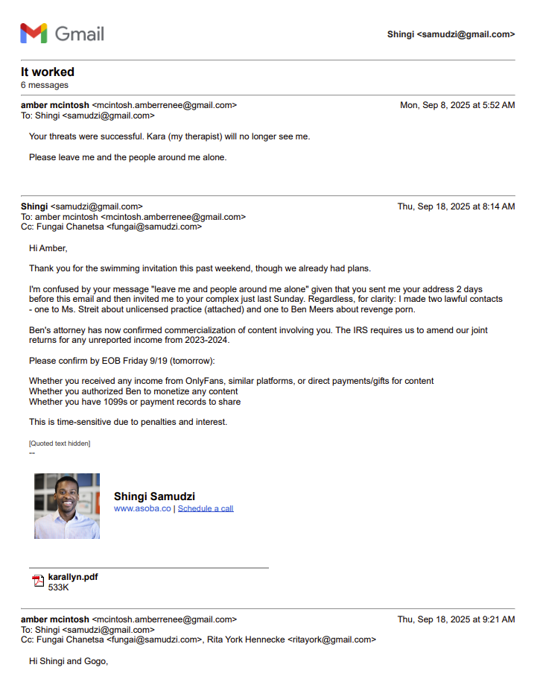
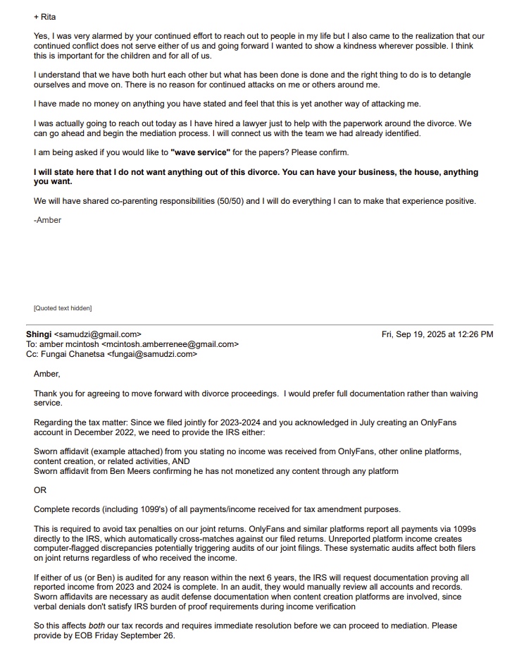
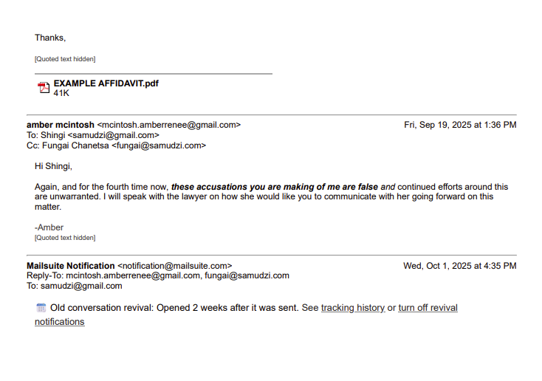

Exhibit N
Exhibit N
Initial email thread with Petitioner’s evasiveness regarding undisclosed OnlyFans income
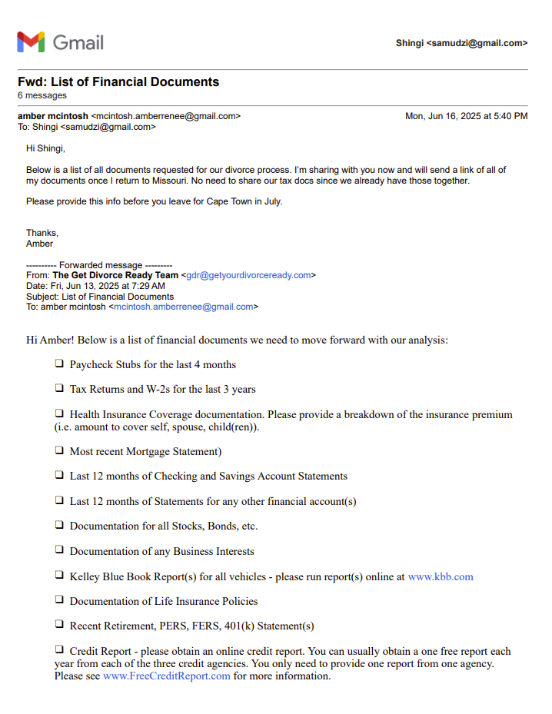
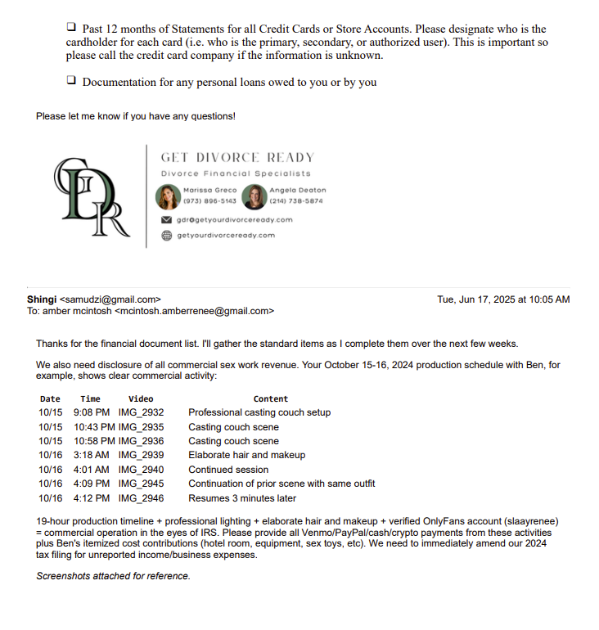
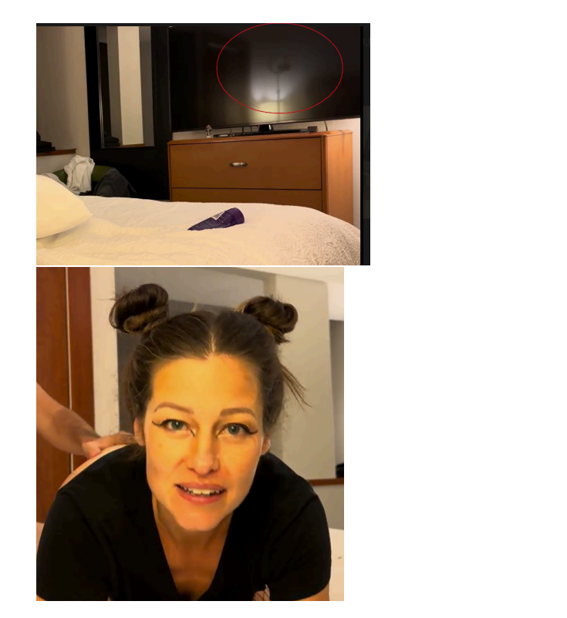
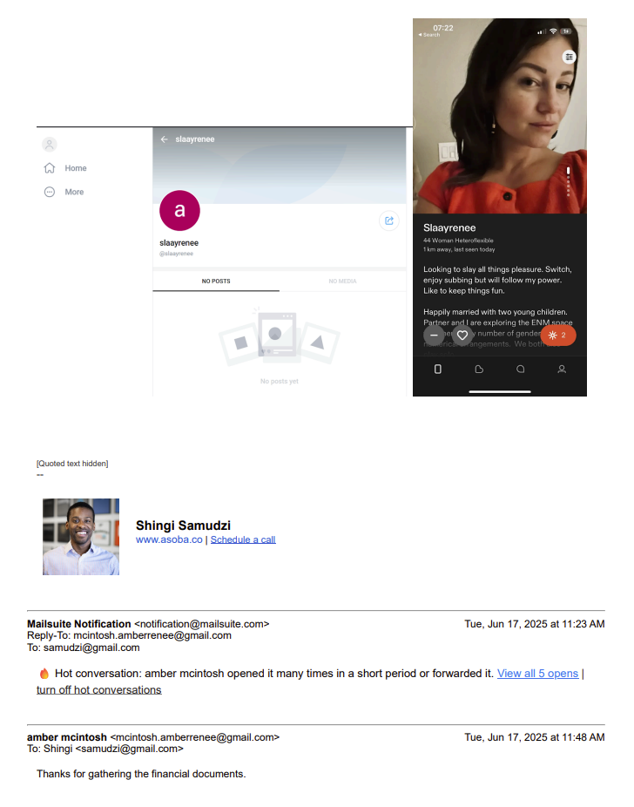
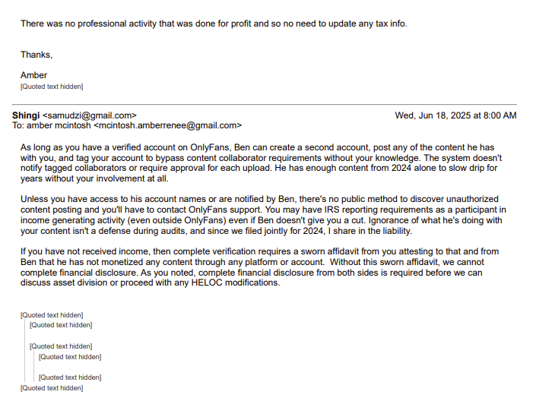

Exhibit O
Exhibit O

Petitioner pattern of bad faith and failure to honor pre existing financial agreements. Note how her tracker completely ignores the rent payments, car payments, school fees and health insurance payments that I made from the time of separation to July 2025
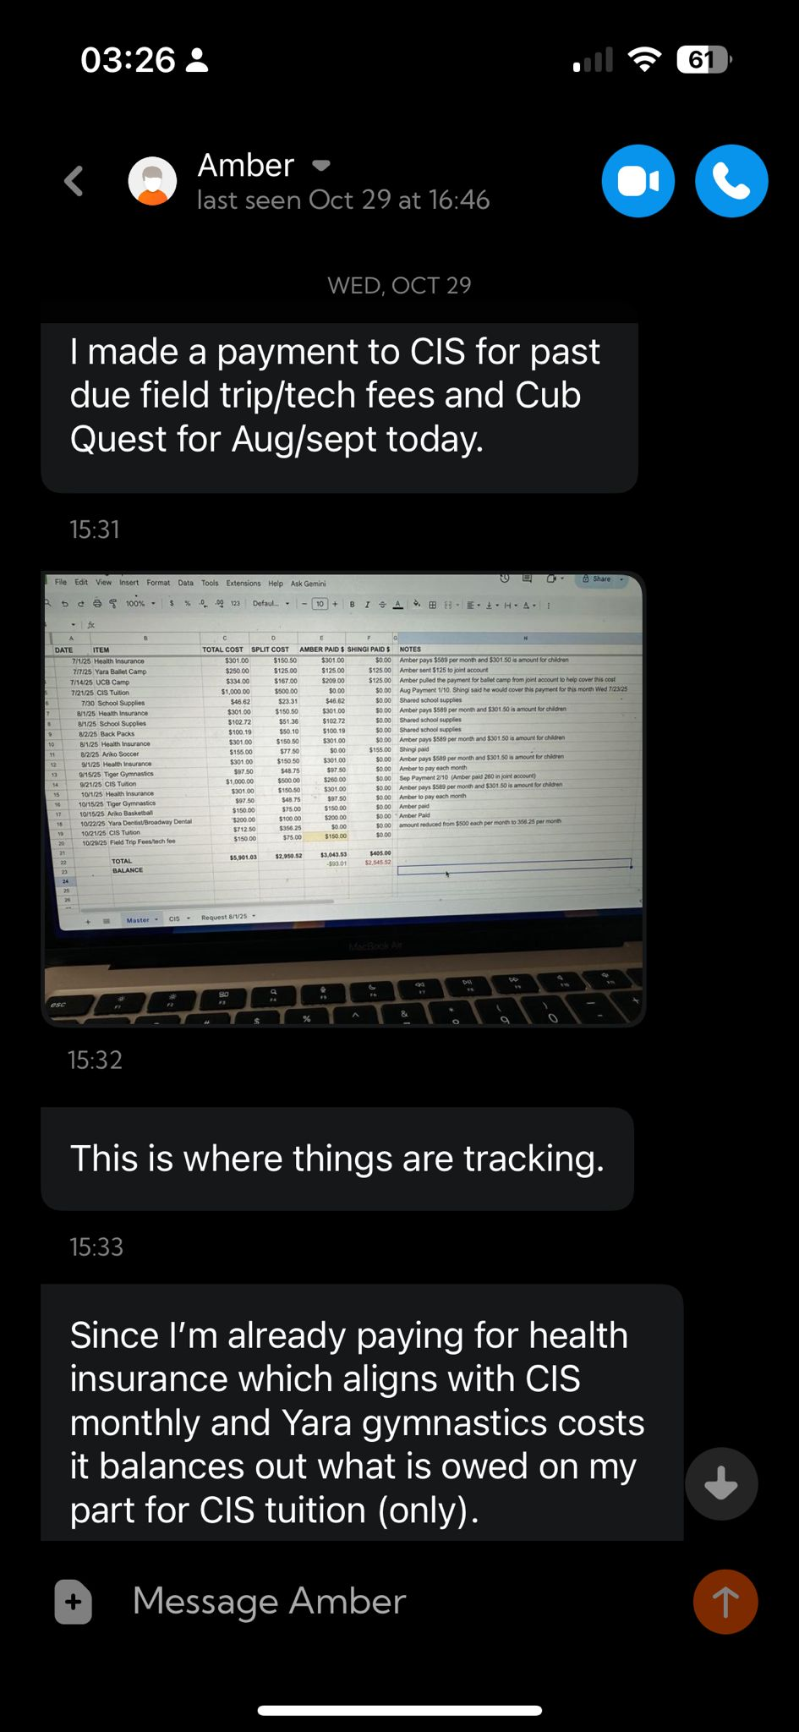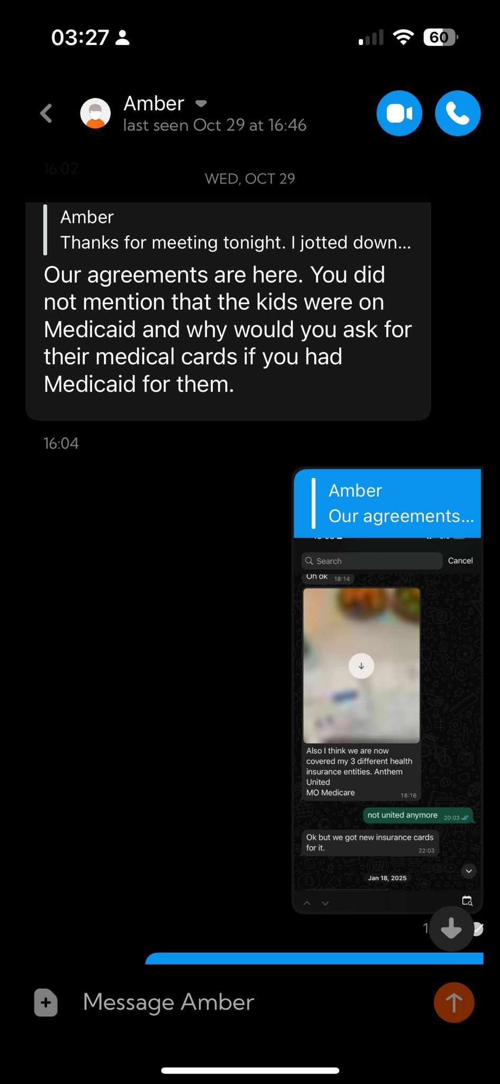
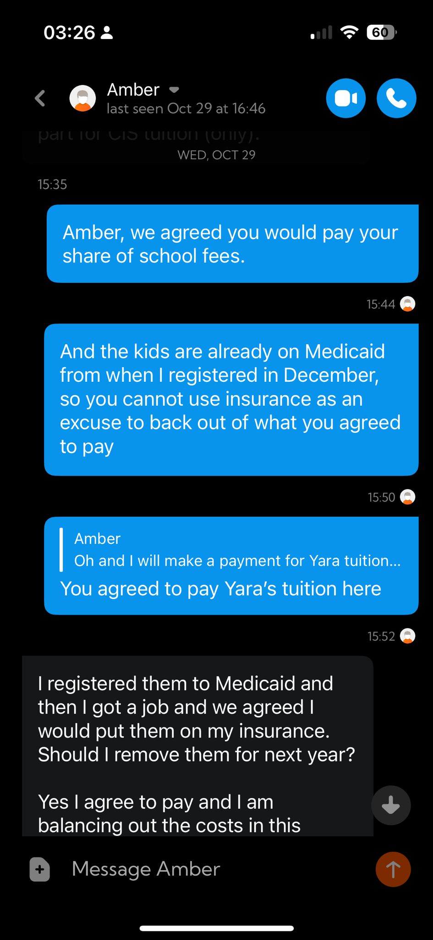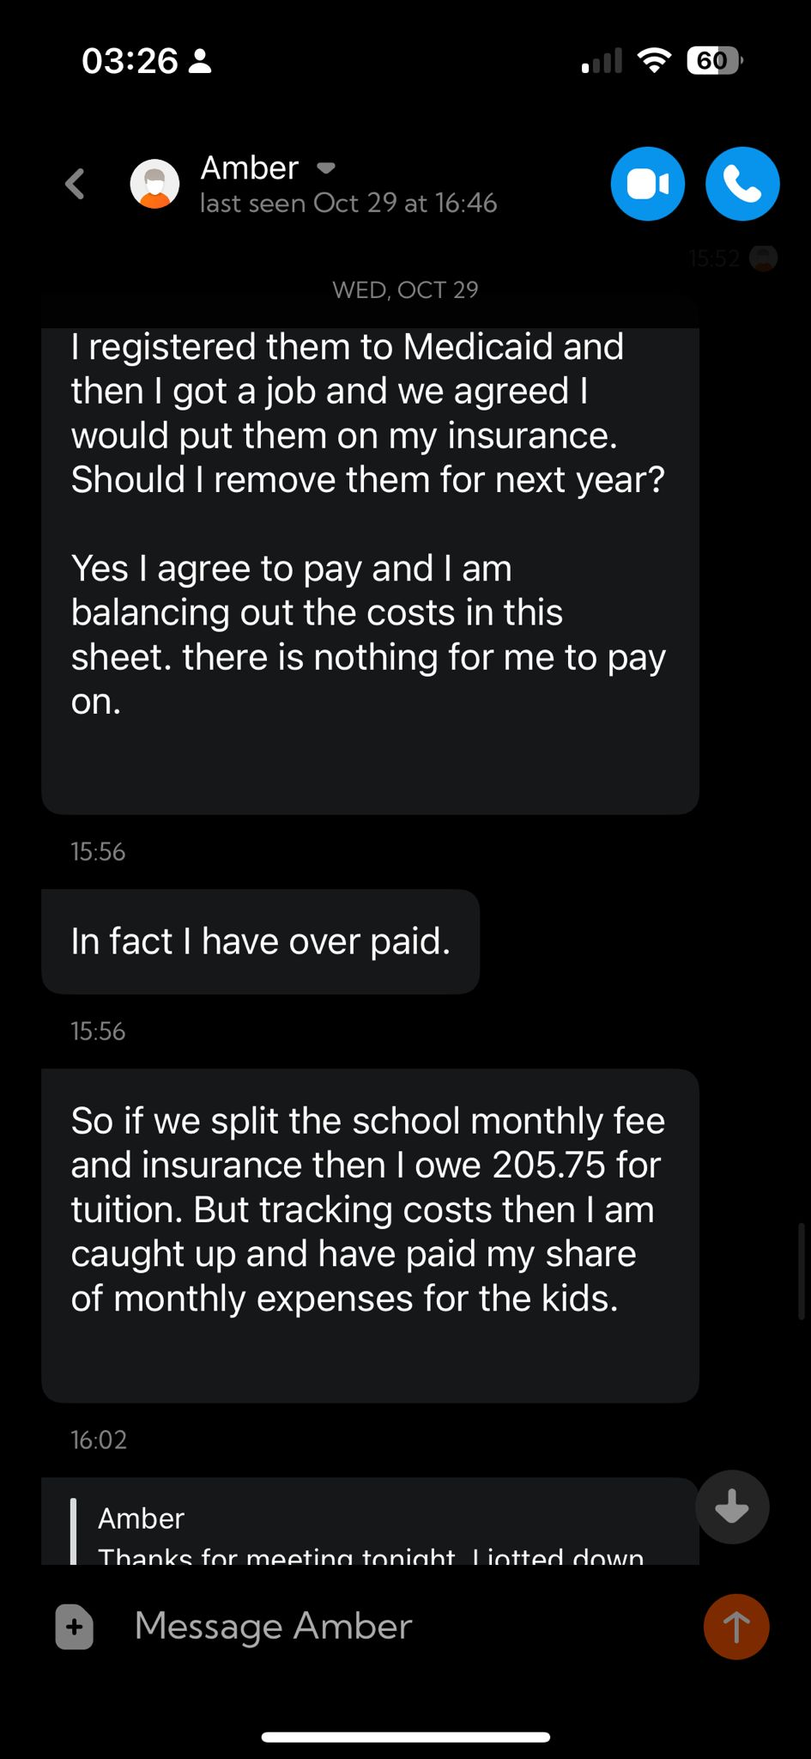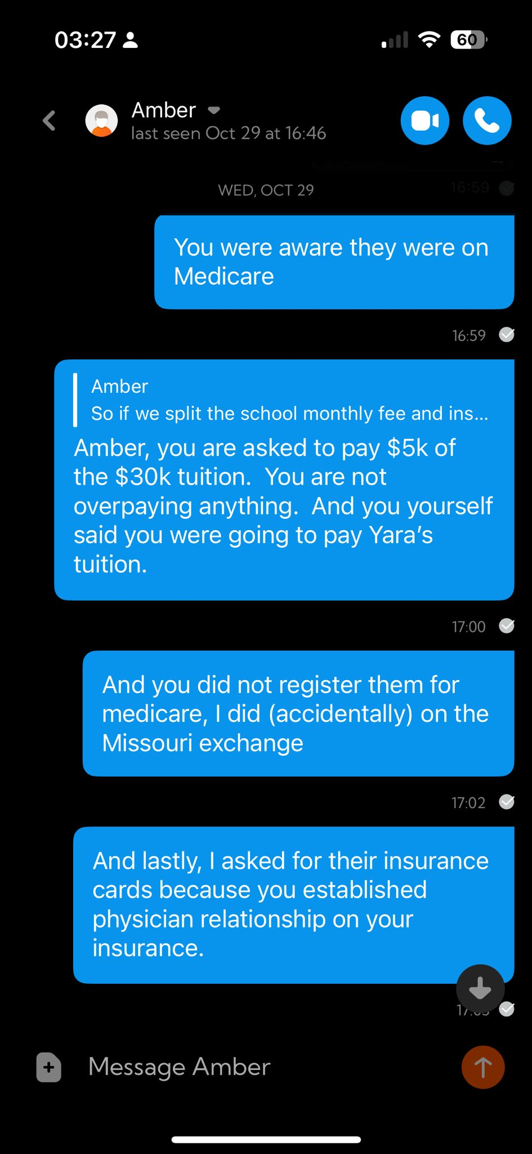

Exhibit P
Exhibit P
Ben Meers’ admission of possession of revenge porn, refusal to delete, and failure to deny claims of potential commercialization of the content. Evidence of coverup by his employer
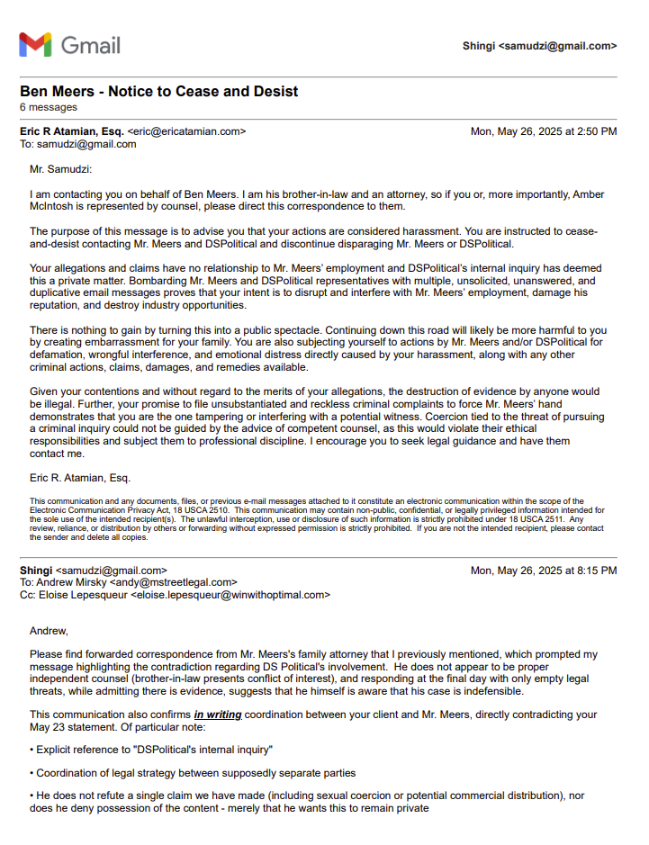
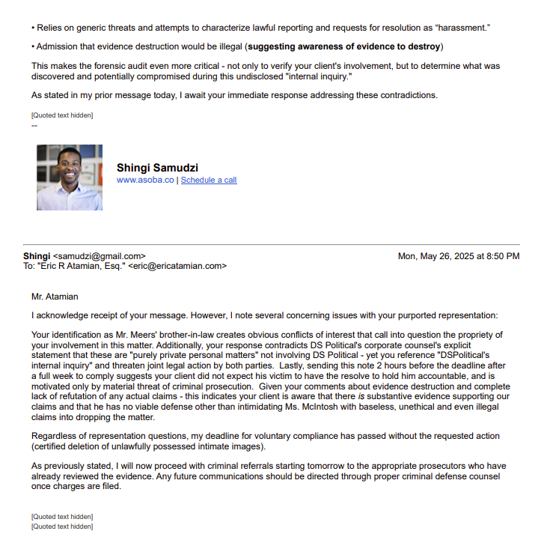

Exhibit Q
Exhibit Q

Title Deed and Mortgage Loan for Newton, KS property showing joint ownership

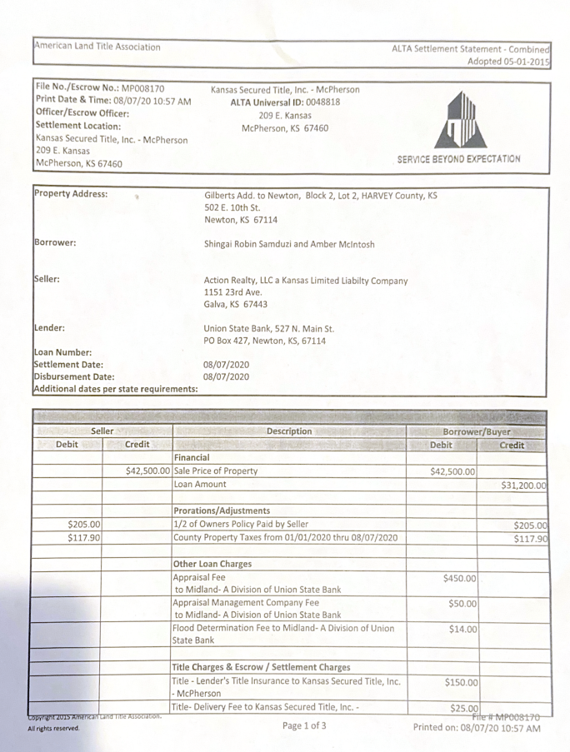

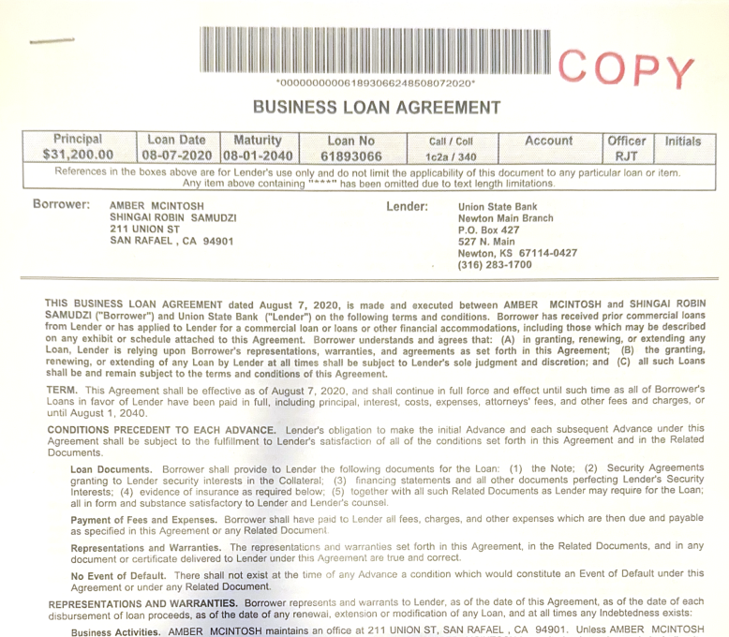

Exhibit R
Exhibit R

My W2 records from 2022 directly refuting Petitioner’s Form 14 claim that she earned 100% of household AGI/income during that year

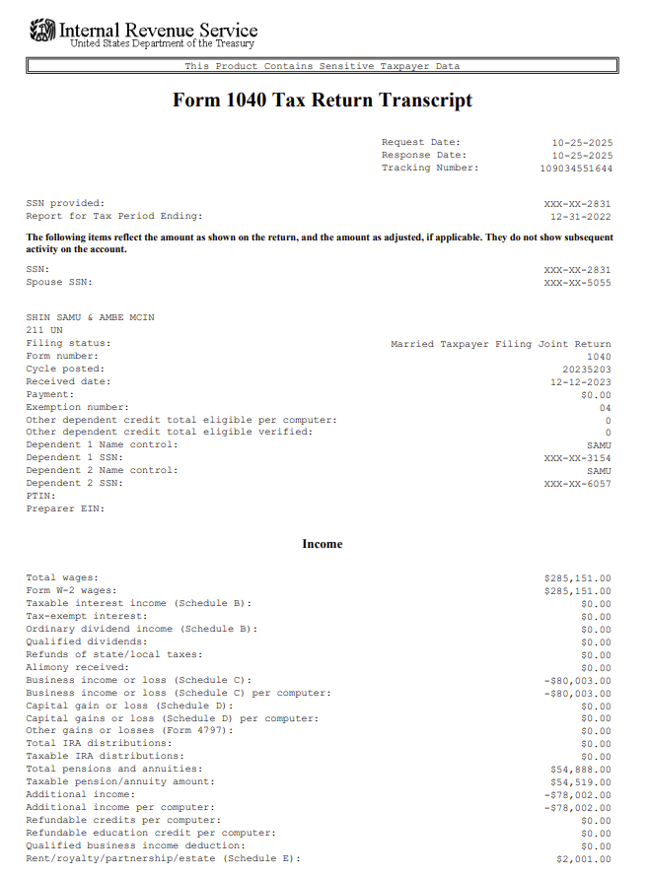
For Tax year 2022, I earned 60% of our $261K AGI
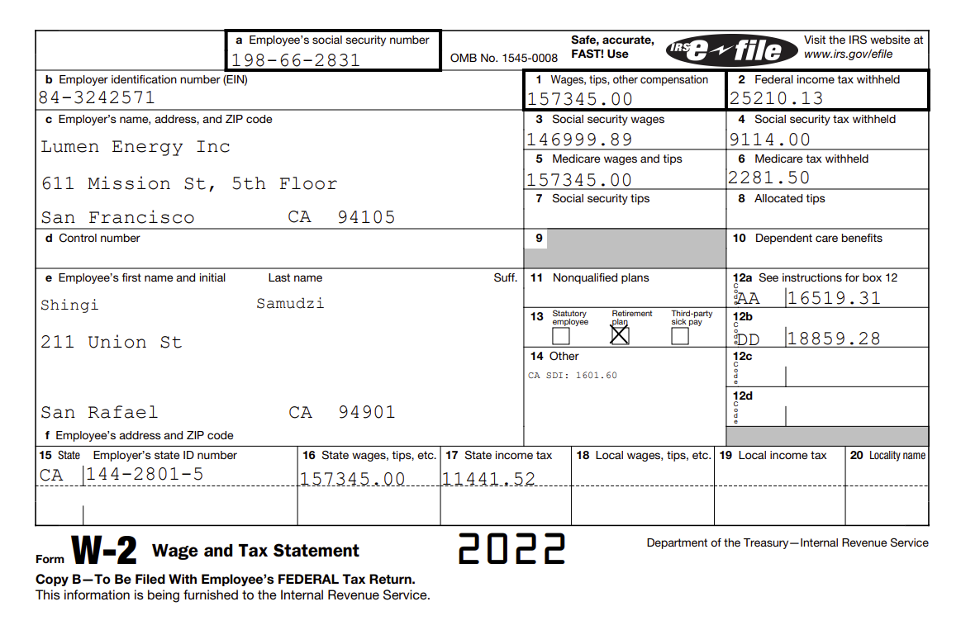

For Tax Year 2023, I earned roughly 24% of total W2 income. Note that Petitioner’s AGI contribution claim for this year was $124k, rather than her actual $114K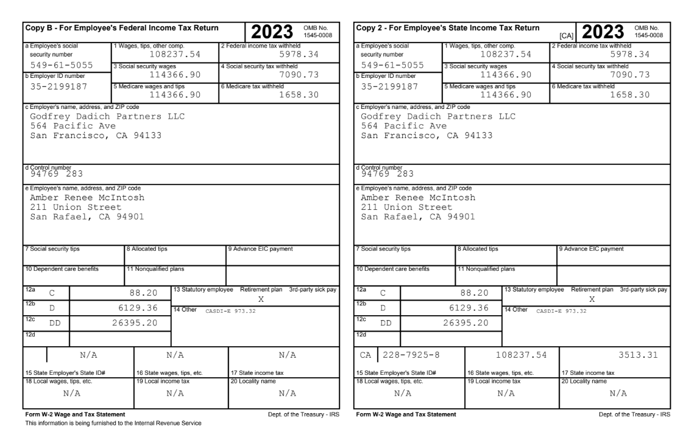
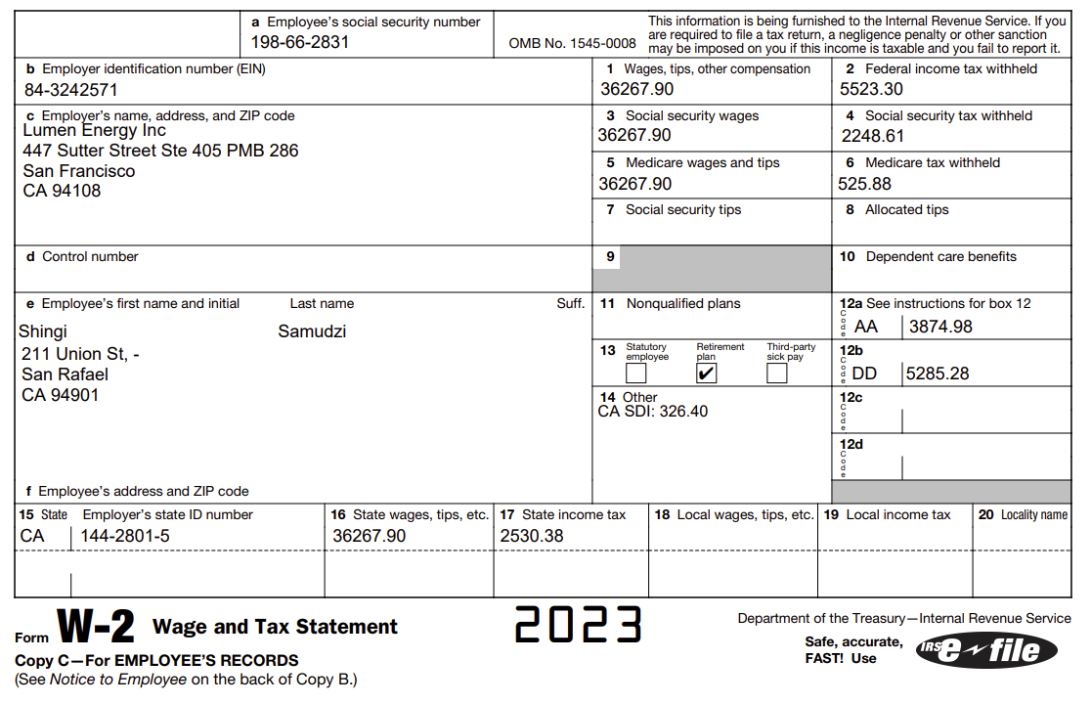

In the 2023 Tax Year, I also raised $220K via my company Asoba Corporation

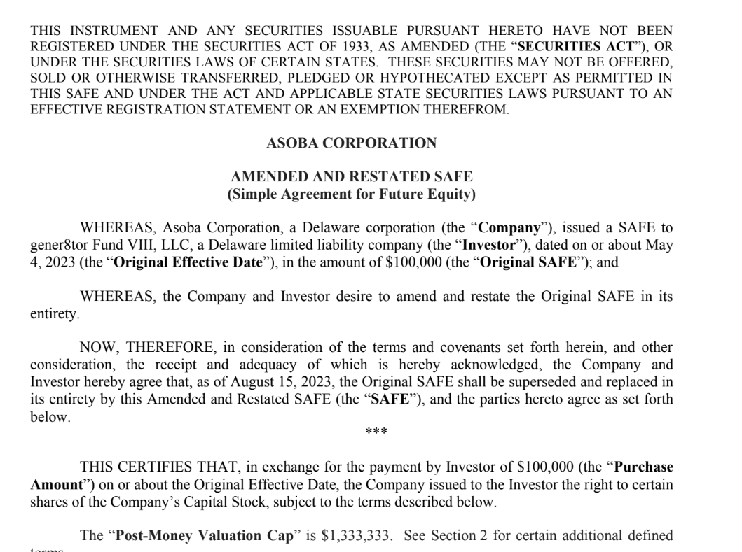

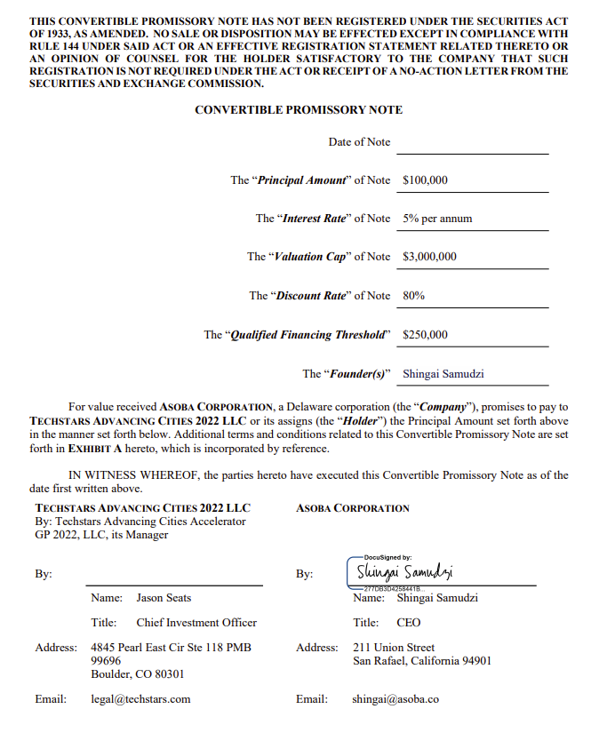
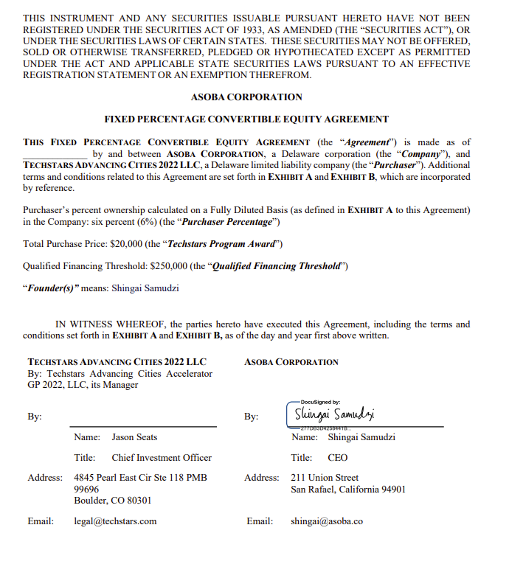

In the 2024 Tax Year, I raised another $200K

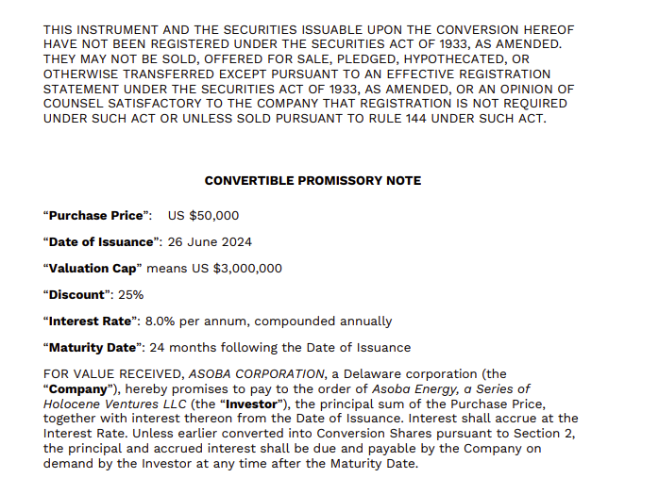
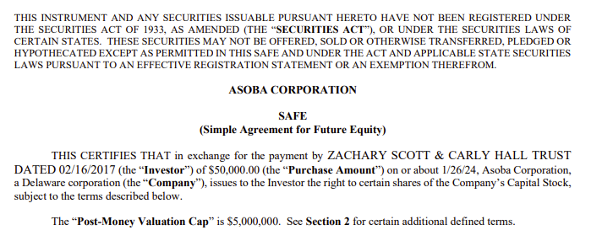
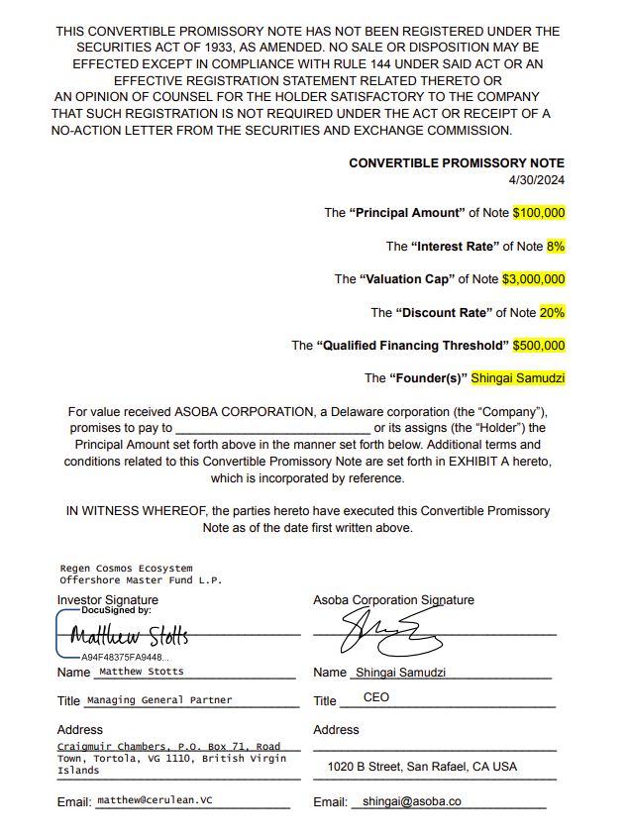

Exhibit S
Exhibit S

Total shared tuition and school fee obligations that Petitioner and I agreed to in July 2025, itemized by the school on November 10 due to Petitioner’s unwillingness to pay any of her financial obligations to that point.

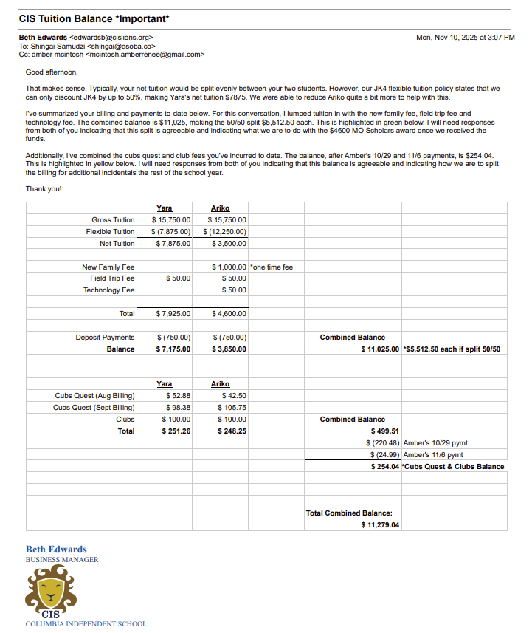

Exhibit T
Exhibit T

My communications with Union State Bank in which I was told that Petitioner was unilaterally working with the bank to modify payment arrangements for our jointly held mortgage, in violation of Fair Lending Practices and the Temporary Restraining Order filed November 7

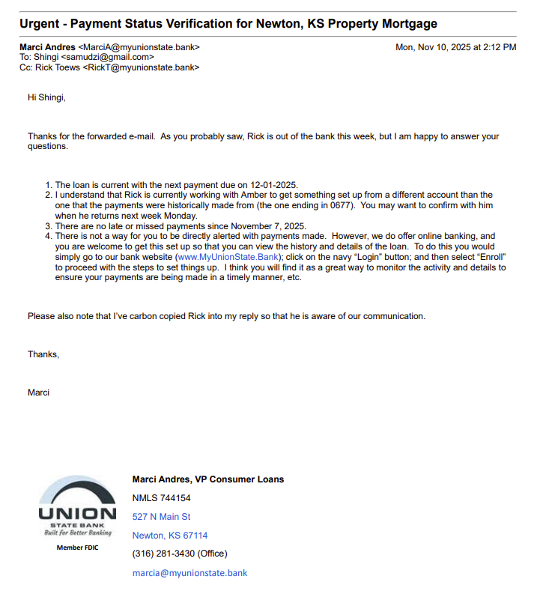

Exhibit U
Exhibit U

Petitioner’s mediation proposal the same day she unilaterally attempted to change our children’s school fee payment agreement terms

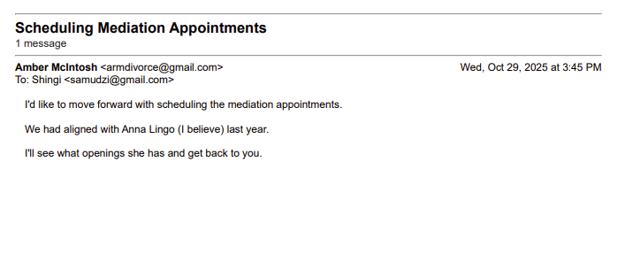

Exhibit V
Exhibit V

Mail tracking showing Senator Josh Hawley’s federal case work team very actively engaged with the requested support in interagency cooperation, even during government shutdown, across my DoJ, FBI, and IRS referrals
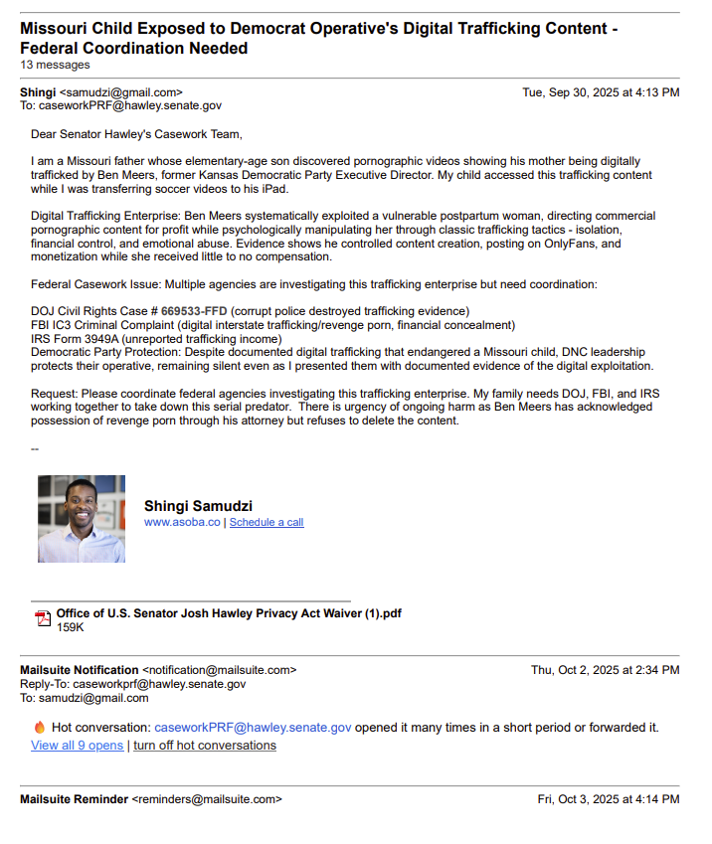

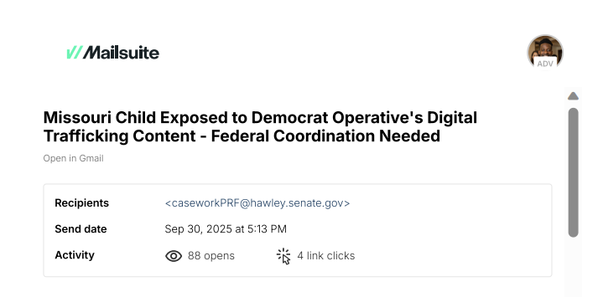
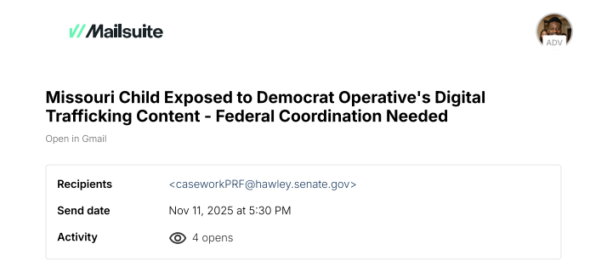

Exhibit W
Exhibit W

Petitioner’s attempt to compel me to destroy evidence of her revenge porn during the active CPD investigation of same. I forwarded this message to Officer Gilstrap, however he decided to ignore this, suggesting collusion with Petitioner to obstruct justice

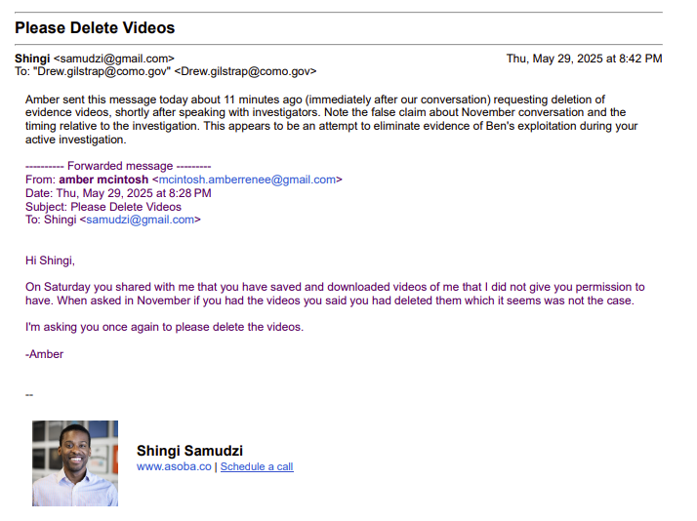

Exhibit Z
Speaker 1: Okay, so your name and your age?

Speaker 2: I am Amber and I'm 44.

Speaker 1: Just be yourself. I'm just going to ask you a bunch of questions and then we'll demo and tape. Okay. Does anyone know you're here? No. No? Okay. Are you seeing anyone now? No. No? Okay.

Speaker 2: I mean I'm married.

Speaker 1: You're married?

Yeah.

Speaker 1: Okay, how long have you been married?

Speaker 2: Ten years.

Speaker 1: Has your husband married you or not? No. No? Okay. When's the last time you had sex?

Speaker 2: Last week.

Speaker 1: Okay. And how many people do you think you've been with?

Speaker 2: Like, my whole life? Yeah. I don't know, maybe like 50 people?

Speaker 1: Okay. Yeah. Okay. Good, sexually active? Mm-hmm. Oh, okay. The last time you had sex was last week. Yeah. Yeah. Oh, good. Okay, and your husband doesn't know you're here now? No. Oh, okay. What would he think if he knew?

Speaker 2: I think he'd be a little upset.

Speaker 1: Okay, but you're happy to be here? Mm-hmm.

Speaker 2: You want to be here?

Speaker 1: Mm-hmm. Okay, so 50 people. Where do you typically meet those guys?

Speaker 2: Um... Get bars or... Um... Through friends. Um... Parties.

Speaker 1: Yeah. Um... How old's the oldest guy you've been with?

Speaker 2: Um... Maybe he's... Fifty now.

Speaker 1: Okay.

Speaker 2: How did you meet him? Through my work.

Speaker 1: Oh, okay. Well, how was that? Tell me more about the fucking guy that you worked with.

Speaker 2: He worked in the kitchen and I worked in the bakery.

Speaker 1: I was at a restaurant.

Speaker 2: Uh-huh. Uh-huh. And... And we just went to a party and got really drunk. And then I went back to his place. And he fucked me.

Speaker 1: Did you fuck him a bunch? No. Just one time? Yeah. In a one night stand?

Speaker 2: Yeah, we did. It was, yeah.

Speaker 1: Okay. And how many of those 50 guys are one night stands, do you think?

Speaker 2: Maybe half of them.

Speaker 1: How old were you the first time you had sex? I was 16. Who was that with?

Speaker 2: My first boyfriend.

Speaker 1: Tell me about your first boyfriend.

Speaker 2: I met him in high school. He was a musician. We had mutual friends, and we started dating, and he had this old car, this Comet. It was a really old, junky car that he would drive around, and we had sex in the back of it, in the back of the field for the first time.

Speaker 1: Okay. A kind of classic first time? Yeah. When you were 16, how old was he?

Speaker 2: In the middle of the country. How old was he? He was 17. He was a year older than me. No, two years older than me. So, yeah.

Speaker 1: Do you typically have adventurous sex, you think, or kinky sex?

Speaker 2: Yeah.

Speaker 1: Yeah? What type of kink?

Speaker 2: I've had sex in a bathroom in a mall before.

Speaker 1: Oh, really?

Yeah.

Speaker 1: When was that?

Speaker 2: Um, just like a month ago.

Speaker 1: Okay. So you like public sex?

Speaker 2: Um, I don't know. Yeah. I'd rather not have public sex, but... Okay.

Speaker 1: What else, what other types of sex do you like?

Speaker 2: Um well I am very much a sub and so I enjoy pleasing other people and um I like to be used and um I like dressing up sexy and making lots of videos.

Prior History with Ben Meers
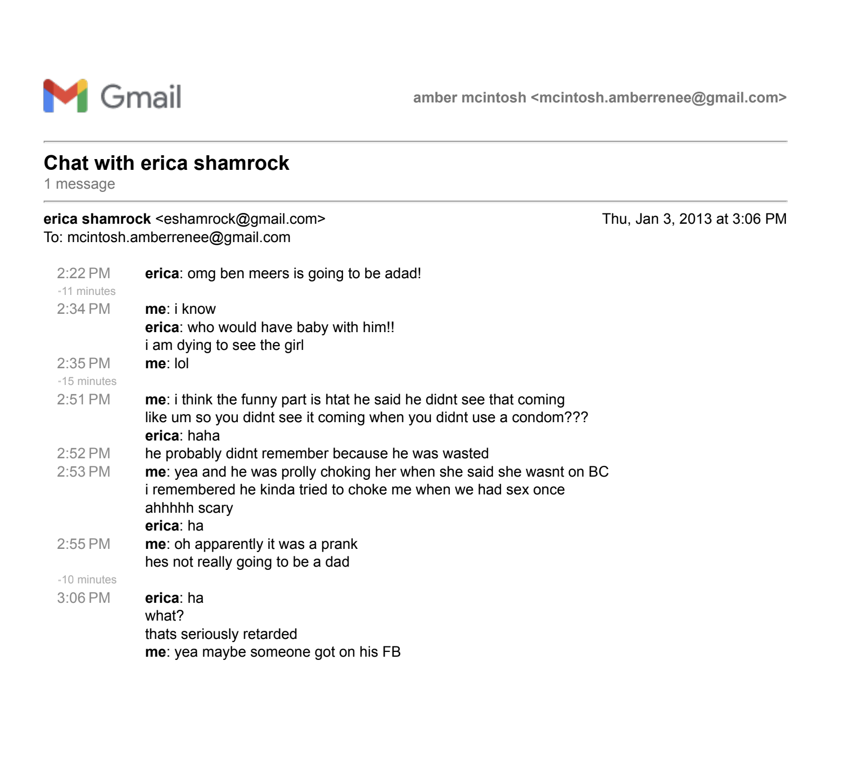

Weaponizing Therapy
former client feedback
Inbox


Shingi <samudzi@gmail.com> | Mar 9, 2025, 1:31 PM
to Anna

Hi Anna,
I hope you're doing well.
After nearly two years of reflection, I wanted to reach out to share some thoughts about my experience in our couples therapy sessions and my decision to end therapy.
Several significant, undisputed events occurred during this period:
- My wife requested an open marriage due to an ongoing extramarital affair.
- She engaged in unprotected sex without my informed consent.
- She shared intimate videos of me without my knowledge or consent.
- She spent our 10th anniversary with her affair partner, despite my objections.
- She repeatedly neglected parental obligations to meet her affair partner, including meeting up with him when our daughter was two weeks old and draining our joint account for a New Mexico trip with him leading to missed tuition payment for our son.
During therapy, these serious ethical breaches went unaddressed because our sessions predominantly centered on comforting Amber’s emotional distress. My own experiences of betrayal trauma were minimized or misunderstood, at times labeled as "unsafe," unintentionally reinforcing harmful racial stereotypes around Black emotional expression.
Upon reflection, I believe the therapeutic environment inadvertently enabled Amber's harmful behaviors and failed to adequately address her underlying mental health struggles. This led to therapy under your care becoming such a harmful experience for me that it has taken me this long to share feedback.
My intention in sharing this is to encourage thoughtful reflection about how unconscious biases might influence therapeutic dynamics and potentially reinforce harmful stereotypes or power imbalances.
Thank you for your consideration.
Sincerely,

--

 | Shingi Samudzi  www.asoba.co | Schedule a call


Anna Chau  <annabchautherapy@gmail.com> | Mar 10, 2025, 3:59 PM
to me

Thank you for your email Singhi.

I have often thought about you and Amber and wondered what occurred in our sessions to have you terminate abruptly. With that said, I want to acknowledge what happened in our actual sessions that ultimately made you feel that it was a harmful experience. There were many things at hand during our session and for me, it was making sure you both felt safe and nurtured while addressing what was going on with Amber's mental health.

I really do appreciate you taking the time to let me know how you feel, especially around race, stereotypes, and power dynamics. I have and will continue to do the work and reflect on the impact I potentially have over my clients.

Sincerely,
Anna
--
Anna Chau, MS, LMFT, CST
Licensed Psychotherapist and Certified Sex Therapist
She/her
Office cell (call or text): 415-212-8260
Email: annabchautherapy@gmail.com
Website: www.annabchautherapy.com

CONFIDENTIALITY NOTICE: The information contained in this communication and any other attachments are intended only for the use of the individual or entity to whom or to which it is addressed, and may contain information that is privileged, confidential and exempt from disclosure under applicable law. If the reader of this communication is not the intended recipient, or the employee or agent responsible for delivering this communication to the intended recipient, you are hereby notified that any dissemination, distribution, copying or disclosure of this communication is strictly prohibited. If you have received this transmission in error, please notify Anna Chau, LMFT immediately by telephone (415-212-8260) and e-mail, and delete the original communication and any attachment from any computer, server or other electronic recording or storage device or medium. Receipt by anyone other than the intended recipient is not a waiver of any attorney-client, physician-patient or other privilege.

If this is an emergency please call (415) 255-3737 Crisis Support Services of San Francisco County for free, confidential support, crisis intervention, and information and referral service for anyone seeking help for mental health and/or substance misuse concerns, available 24 hours a day, 7 days a week, 365 days a year.

Shingi <samudzi@gmail.com> | May 19, 2025, 12:14 AM
to Anna

Hi Anna,
Thank you for your reply. I do want to emphasize that I don't blame you for anything that's happened, and I know you have many successful and happy clients.
That being said, your response rubbed me badly the wrong way and felt dismissive, in particular:
“…making sure you both felt safe and nurtured while addressing what was going on with Amber’s mental health.”
That description does not match my experience which involved:
- No check-ins on my safety after direct comments of me saying I did not feel safe in sessions, that I was burnt out performing emotional labor for a partner with significant mental health issues, and that she was acting in abusive ways towards not just me but our children.
- Dismissal of my trauma in your July 25 reply you seized on my own description of my email as “a wall of text” and used it to deflect, instructing me to CC Amber - the very person causing those harms - instead of engaging with or addressing any of the serious issues I’d raised, either via email or in session.
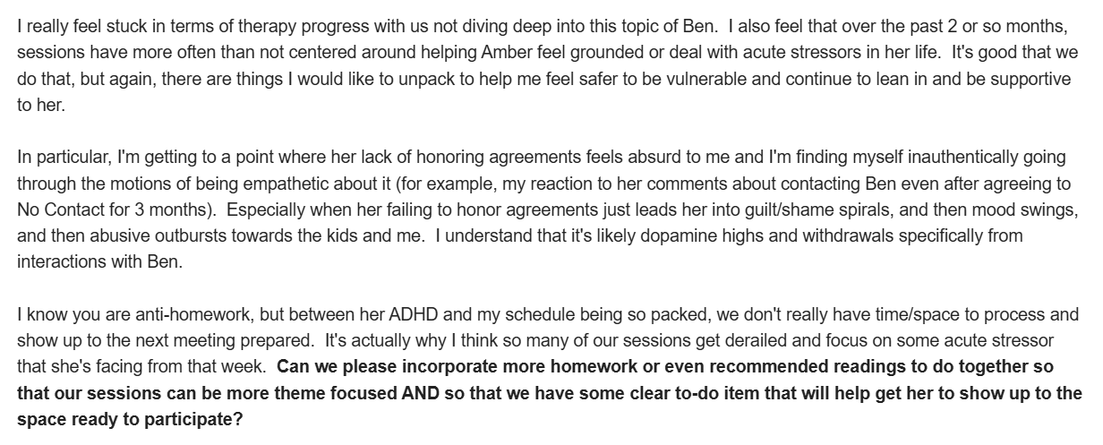
- One-sided co-regulation in my email above, I also pointed out that I didn't see real progress in therapy because sessions constantly kept getting derailed by Amber's emotional dysregulation. We spent far more energy focused on stabilizing her latest acute emotional crisis than any of the core issues that brought us to you in the first place.
- Uncritical adoption of Amber’s narrative Amber’s polished use of “ethical non-monogamy” language and her “mother seeking identity growth through sexual exploration” affect crafted a love story with Ben compelling on the surface but that fell apart under basic scrutiny. In reality, their dynamic was driven by her compulsive limerent addiction that Ben was exploiting to coerce her into producing dozens of self-erasing, degrading sex videos over their 5 year affair. In her disordered state, her perception of safety was tied to continuation of the affair, even though the actual relationship with Ben was very unsafe.
If genuine mutual safety had been your goal, you would have:
- Directly addressed my trauma in the same way you focused attention on Amber's dysregulation
Acknowledged that non-consensual video-sharing (a misdemeanor in California), undisclosed unprotected sex, and repeated boundary violations are serious harms that demand direct and immediate therapeutic (if not legal) attention.
- Equitably held space
Avoided privileging Amber’s discomfort or allowing third rail issues in our marriage to be repeatedly tabled without ever having direct conversation about it. The pattern was Uncomfortable Subject -> Amber Floods Emotionally -> Subject Tabled -> Focus Shifts to Co-Regulating Amber -> Session Ends, Subject Unresolved.
- Assessed risk in non-monogamy
Recognized that Amber’s diagnosed ADHD + hypomania/bipolar II, and history with predatory partners made non-monogamy unsafe, and recommended addressing those vulnerabilities before proceeding.
- Questioned the ethical framework of ENM established via infidelity
Used your professional experience and expertise to note that facilitating open-marriage logistics before rebuilding foundational trust or addressing relational betrayals would both set us up to fail as well as anchor her affair in her mind as "legitimate" especially since using ENM to “legalize” existing infidelity is a strong predictor of relational collapse.
- Offered emotional scaffolding
Responded constructively to my repeated requests for between-session resources and concerns about lack of meaningful integration of concepts uncovered in-session instead of brushing them off.
- Reflected on racial and gender bias
Recognized that If Amber was the one telling you privately about abuse towards her and the kids at home, you would have never asked her to cc me about it in the future. If you are earnest about doing the work, you absolutely need to ask yourself why you didn't think it was important to follow up with me about the abuse I mentioned happening at home. Whether it's gendered understanding of abuse or racial empathy gap (or both)
You aren’t to blame for what happened, nor do I think you acted with ill intent. Amber and I were attempting to resolve a second-order issue - navigating non-monogamy - without first addressing the deeper patterns of trauma and emotional dysregulation (especially her hypomanic cycles) that made any meaningful integration of therapy takeaways impossible. I do believe, however, that you could and should have taken stronger leadership at the outset by offering a clear relational diagnostic and structured roadmap for our work together. Frankly, everyone who supported Amber therapeutically over these last two years enabled her vague “finding my truth” narrative without ever questioning the immense harm her behaviors inflicted on our family, friends, and her own well-being.
If you can offer a substantive response to these concerns, I welcome it. Otherwise, I consider this matter closed.
Sincerely,
--

 | Shingi Samudzi  www.asoba.co | Schedule a call

Tab 28
1 Memorial Drive / Kansas City, Missouri 64198 / www.kansascityfed.org
INTERNAL FR/OFFICIAL USE // SECURE EXTERNAL
February 27, 2026
SENT VIA SECURE E-MAIL
Shingai Samudzi
211 Union Street
San Rafael, California 94901

Dear Mr. Samudzi:
This letter is in response to your correspondence concerning your complaint regarding Union State Bank (the
bank) located in Arkansas City, Kansas. In your complaint, you alleged discrimination based on marital status
and stated that the bank acted unethically during active divorce proceedings with your estranged wife. You
stated that the bank violated Regulation B - Equal Credit Opportunity Act (ECOA) by showing preferential
treatment to your wife when it approved her application for a HELOC to be secured by your jointly owned
rental property. You further stated that the bank provided exclusive access to details about the existing loan
account, and ignored requirements set forth in a temporary restraining order implemented during active divorce
proceedings. You stated that you want an immediate investigation of the bank’s Regulation B compliance
program.
We also interviewed you by telephone on December 10, 2025, to obtain additional information about your
allegations against the bank. During the interview, you provided further details regarding your concerns, stating
that one of the bank’s employees actively coordinated with your wife to structure transactions that excluded you
based on your marital status and attempted to coerce you into signing security documents for her loan.
The Federal Reserve Bank of Kansas City is responsible for ensuring that institutions it supervises comply with
applicable federal consumer protection laws and regulations, including the Fair Housing Act (FHA) and the
Equal Credit Opportunity Act (ECOA). You have alleged discrimination involving a real estate transaction.
The FHA prohibits discrimination related to housing transactions on the basis of race, color, national origin,
religion, sex, handicap, or familial status (having children under the age of eighteen). The ECOA prohibits
discrimination in all credit transactions on the basis of race, color, national origin, religion, sex, marital status,
or age (provided that the applicant has the capacity to enter into a binding contract); the fact that all or part of
the applicant's income is derived from a public assistance program; or because the applicant has in good faith
exercised any rights under the Consumer Credit Protection Act. The FHA and ECOA provide for enforcement
of these rights by the appropriate federal agencies or through private legal actions by the affected individual.
Because the complaint you submitted alleged discrimination on the basis of marital status, we reviewed your
complaint as it relates to the ECOA.
In addition to interviewing you and reviewing your written complaint, we asked the Bank to provide a response
to your concerns and any supporting documentation to us. We reviewed this information along with information
you provided and we have now completed our investigation of your complaint. Based on the evidence we
obtained and reviewed during our investigation, we were not able to reach a determination that the bank’s
actions were the result of discrimination on the basis of marital status or violated any requirements outlined in
Regulation B §1002.7.
2
INTERNAL FR/OFFICIAL USE // SECURE EXTERNAL
Our investigation included a review and evaluation of documentation provided by you and the bank including
your email communications with the bank, documentation and disclosures associated with your joint
commercial loan, the bank’s fair lending and loan policies, and facts collected during interviews conducted with
you and bank staff. Our investigation showed that the bank was responsive to your requests for information and
account access regarding your existing loan with Ms. McIntosh. Additionally, our review of loan and mortgage
disclosures revealed no clauses specifically addressing loan payment methods. Documentation showed that the
bank recently attempted to assist you with setting up online banking access to view loan details and payment
history, but that access has not yet been established.
As our investigation is complete, we are closing your complaint. Please note that you have the right to consult
with a private attorney to discuss your concerns and rights under applicable federal or state law. Additionally,
you have the right to contact the relevant state banking agencies to file a complaint. Please note that filing
deadlines or statutes of limitations vary based on the laws at issue and may be as short as two years from the
date the alleged discriminatory event occurred. It is your responsibility to consult with a private attorney
regarding how those laws may affect your claims, if any.
We hope that you find the information provided useful. If you have any additional questions, please feel free to
contact us at consumer@kc.frb.org.
Sincerely,
Complaints Examiner

